

**ETL**

**Homework #3**

March 2022



Data 228 - Big Data Technologies and Applications

Department of Applied Data Science

San Jose State University

***Faiza Ayoun (015960139)***

***Harsimran Kaur (016003468)***

***Pooja Malage (015294760)***

***Saranya Pandiaraj (015304497)***

Table of Contents

Setting up IAM permissions for AWS Glue 3

Step 1: Create an IAM Policy for the AWS Glue Service 3

Step 2: Create an IAM Role for AWS Glue 4

Step 3: Attach a Policy to IAM Users That Access AWS Glue 6

Step 4: Create an IAM Policy for Notebook Servers 7

Step 5: Create an IAM Role for Notebook Servers 9

Step 6: Create an IAM Policy for SageMaker Notebooks 10

Step 7: Create an IAM Role for SageMaker Notebooks 13

Setting Up DNS in Your VPC 16

Setting Up Your Environment to Access Data Stores 17

Amazon VPC Endpoints for Amazon S3 17

Setting Up a VPC to Connect to JDBC Data Stores 20

Set up access for Amazon Redshift data stores 20

Set up access for Amazon RDS data stores 21

Setting Up Your Environment for Development Endpoints 23

Setting Up Your Network for a Development Endpoint 23

Setting Up Amazon EC2 for a Notebook Server 24

Setting Up Encryption in AWS Glue 25

AWS Glue Console Workflow Overview 38

References 44

# Setting up IAM permissions for AWS Glue

## Step 1: Create an IAM Policy for the AWS Glue Service

1. Create policy and update JSON

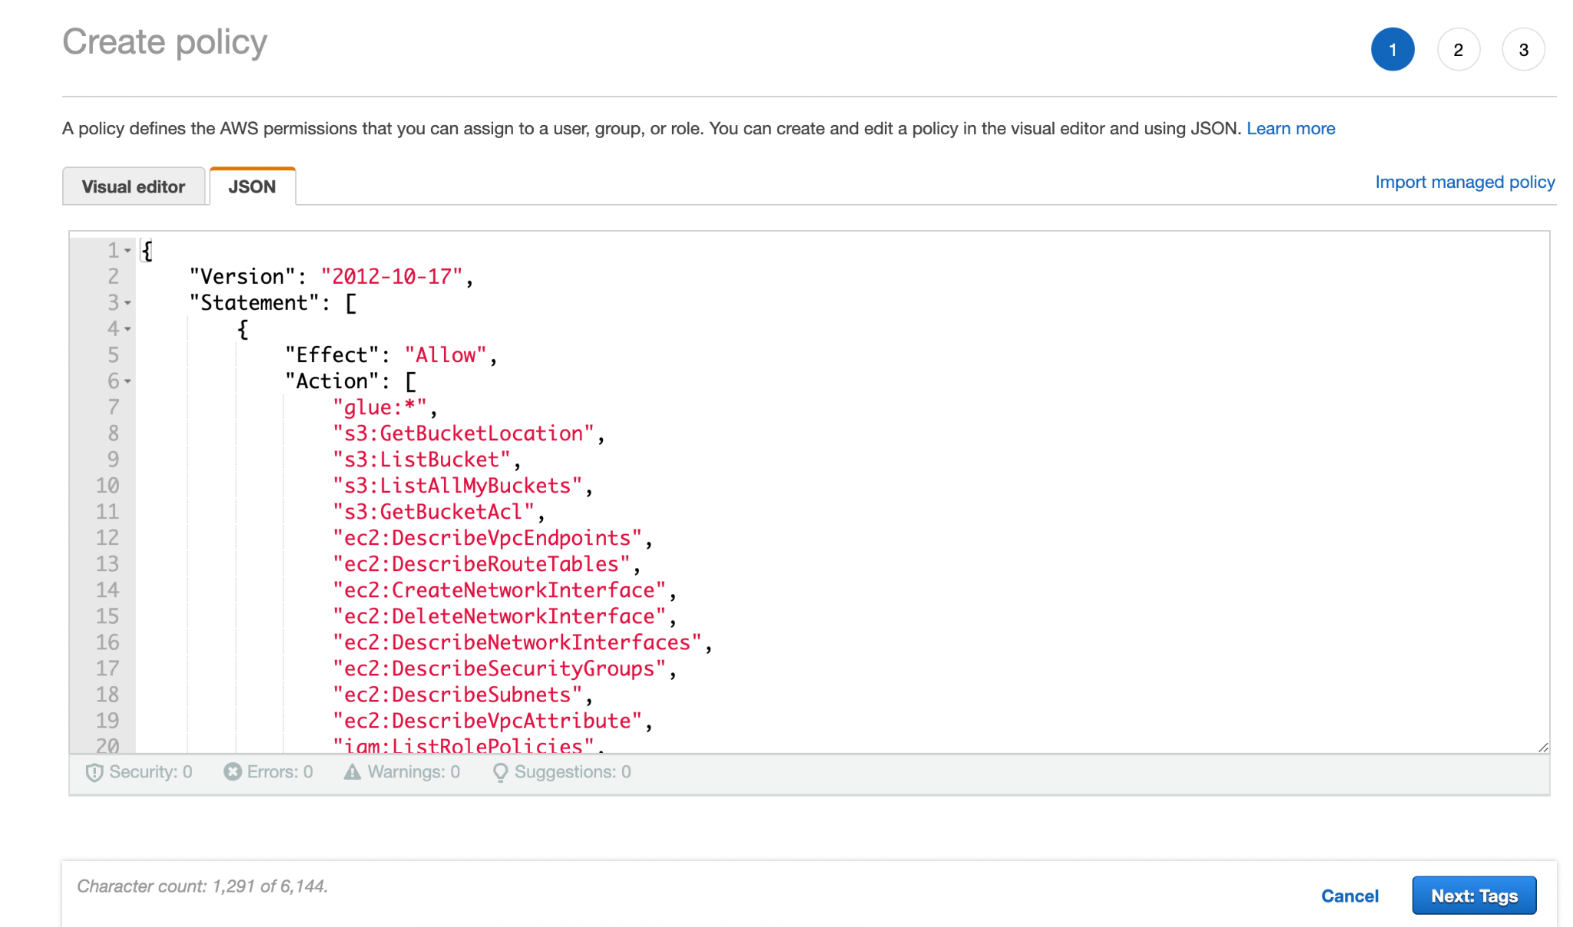

1. Review Policy and Click “Create” button.

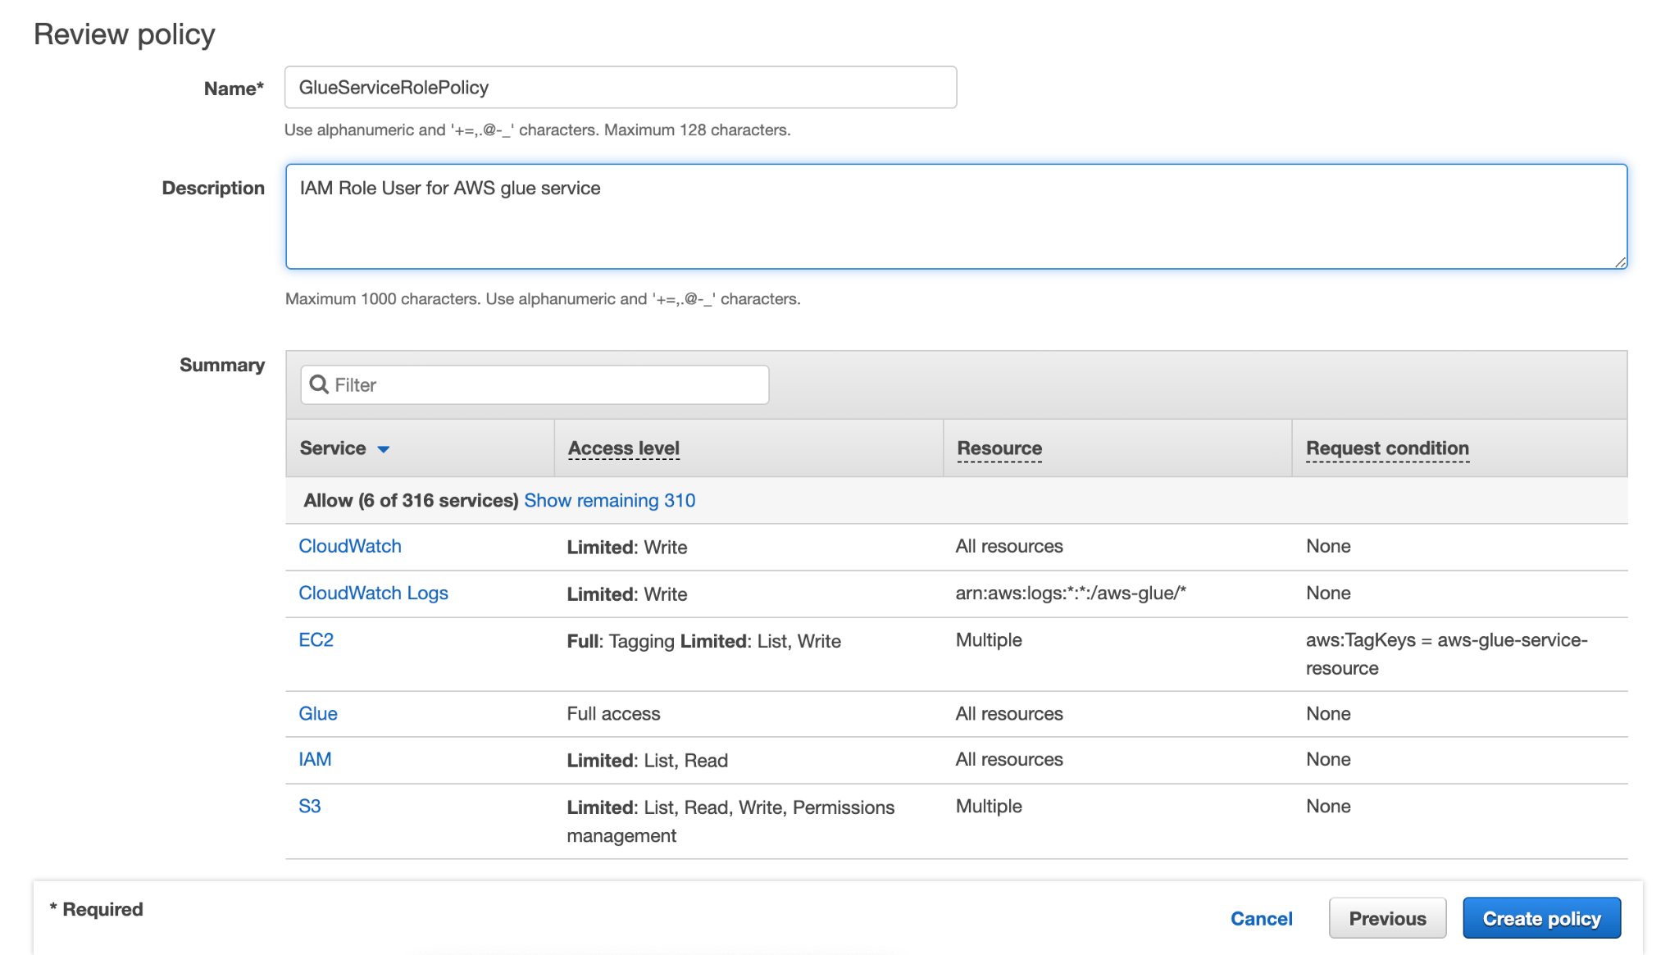



## Step 2: Create an IAM Role for AWS Glue

1. Create IAM Role and select trusted entity.

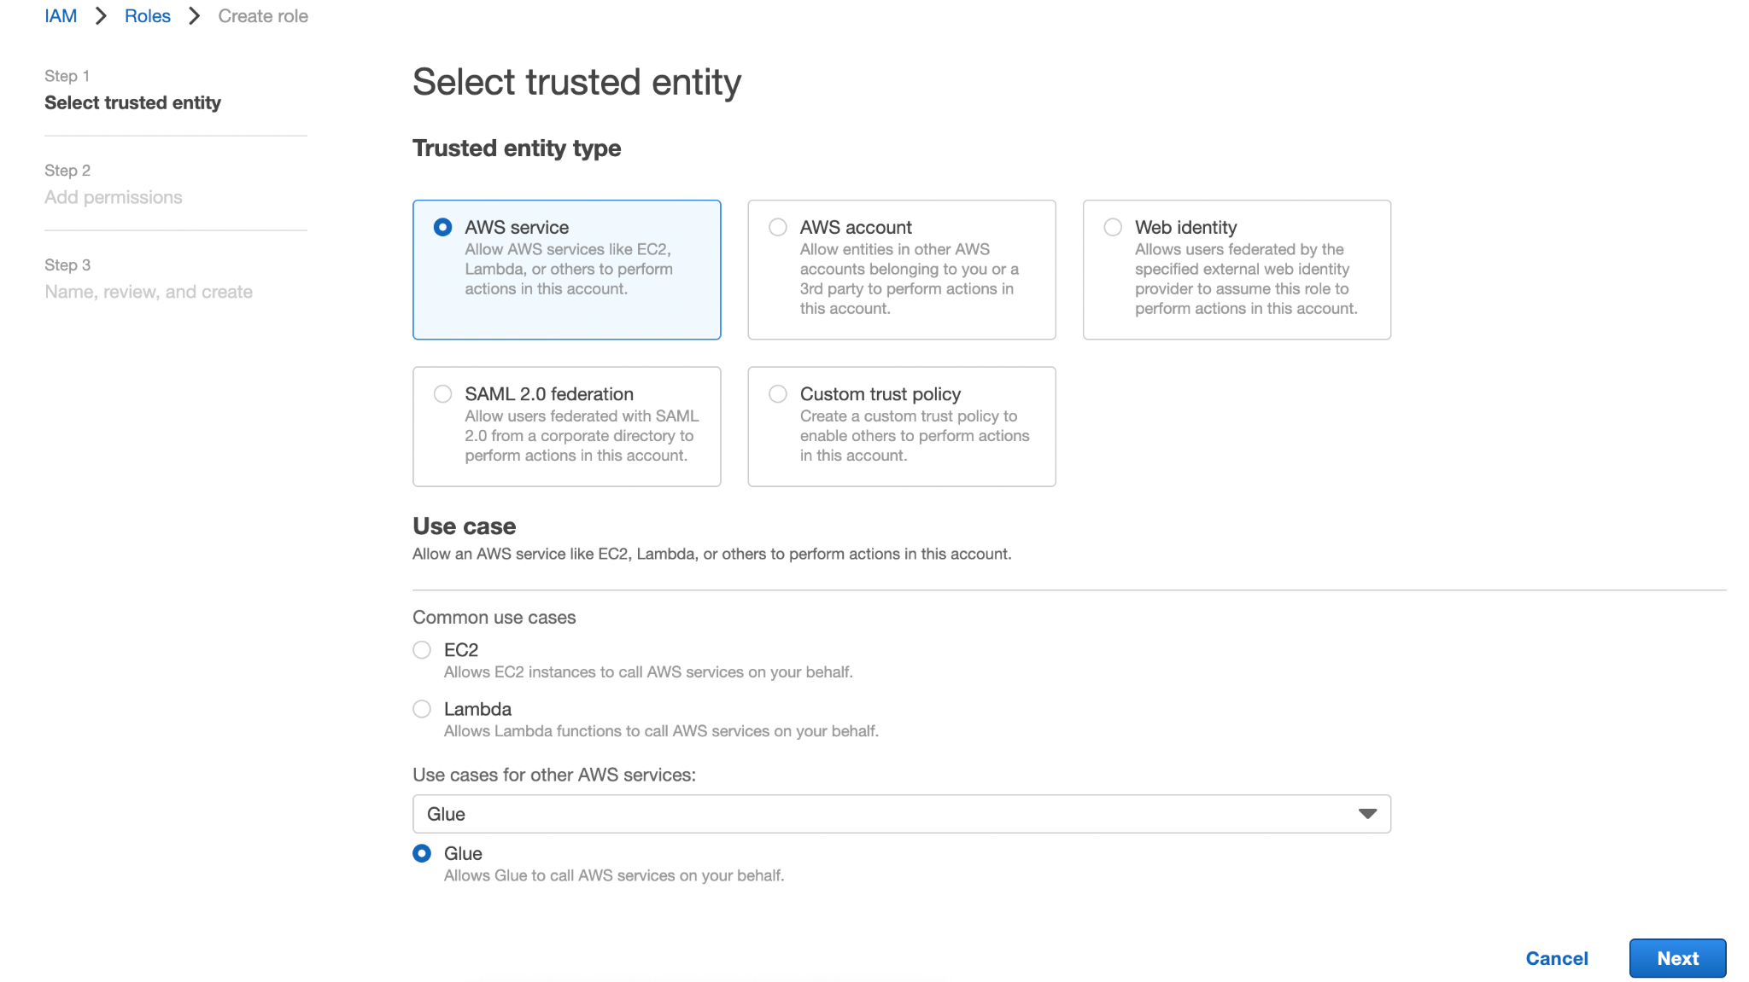

1. Give role name and description.

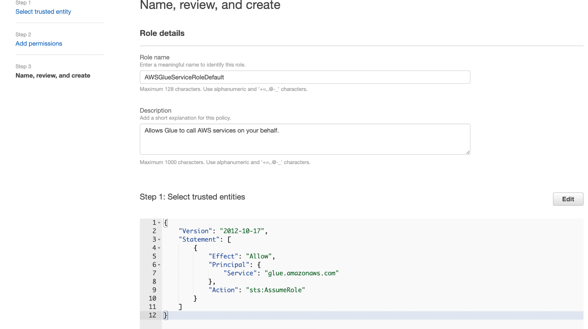

1. Add required permission to that role and Click “Create role.

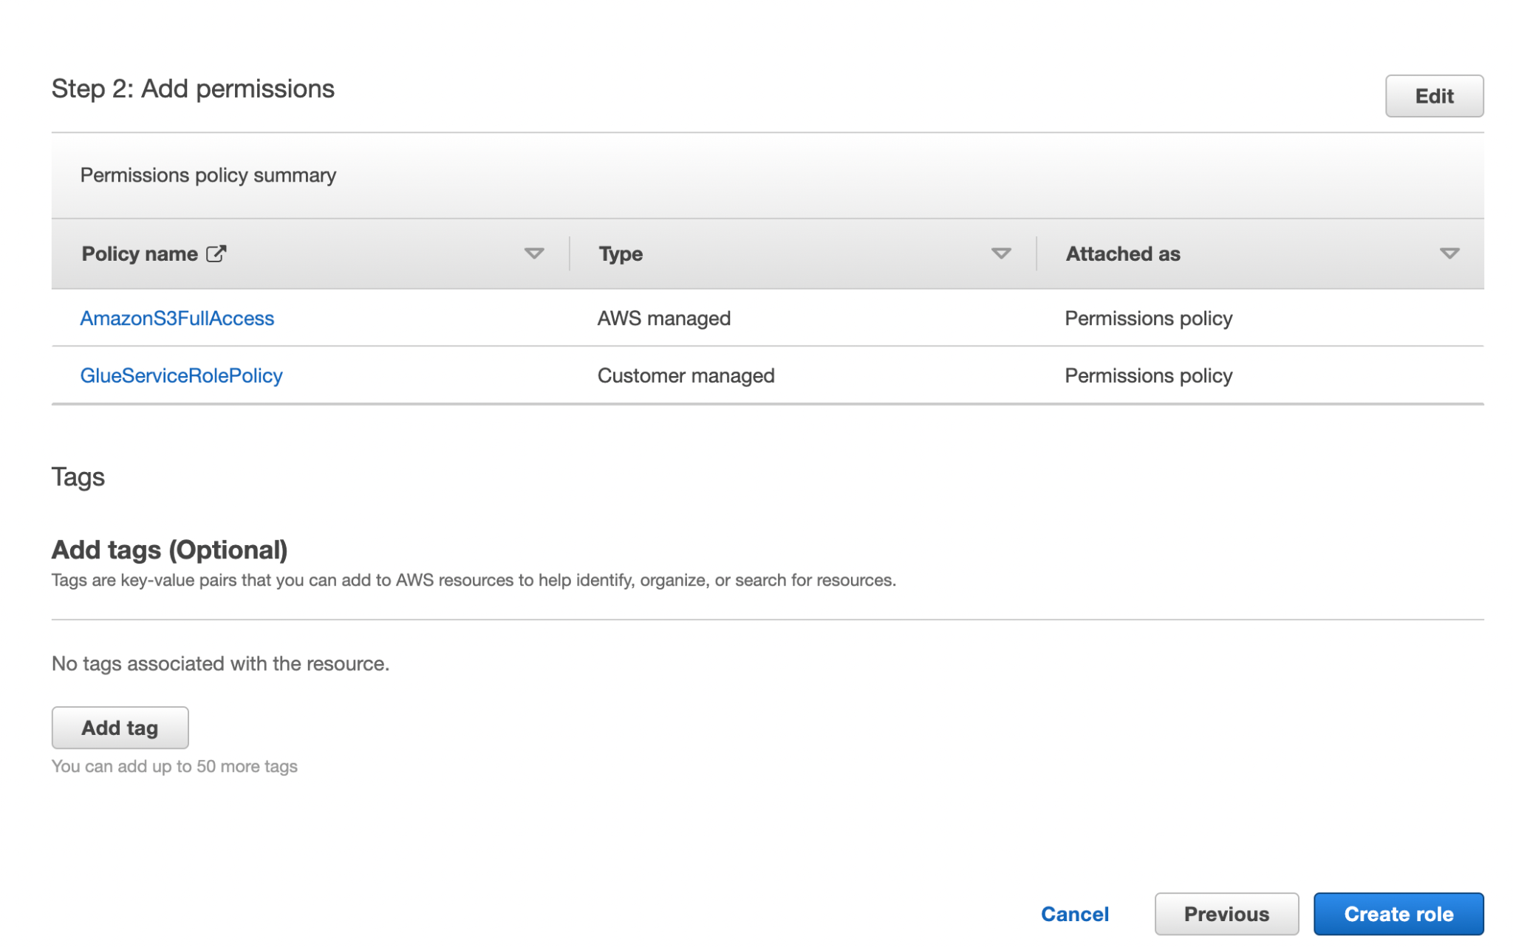

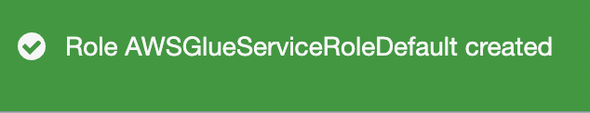

## Step 3: Attach a Policy to IAM Users That Access AWS Glue

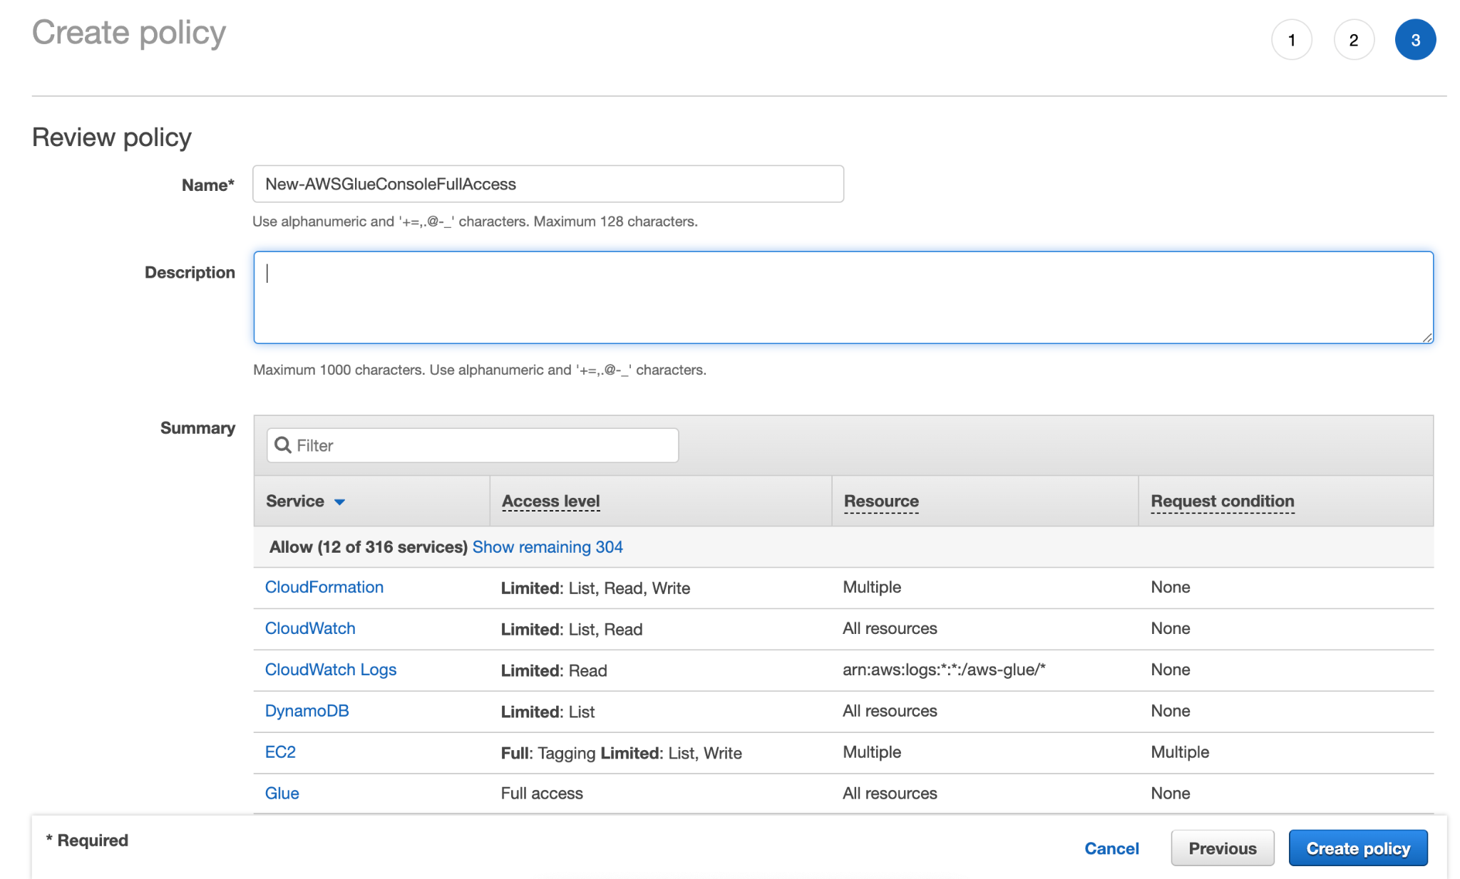



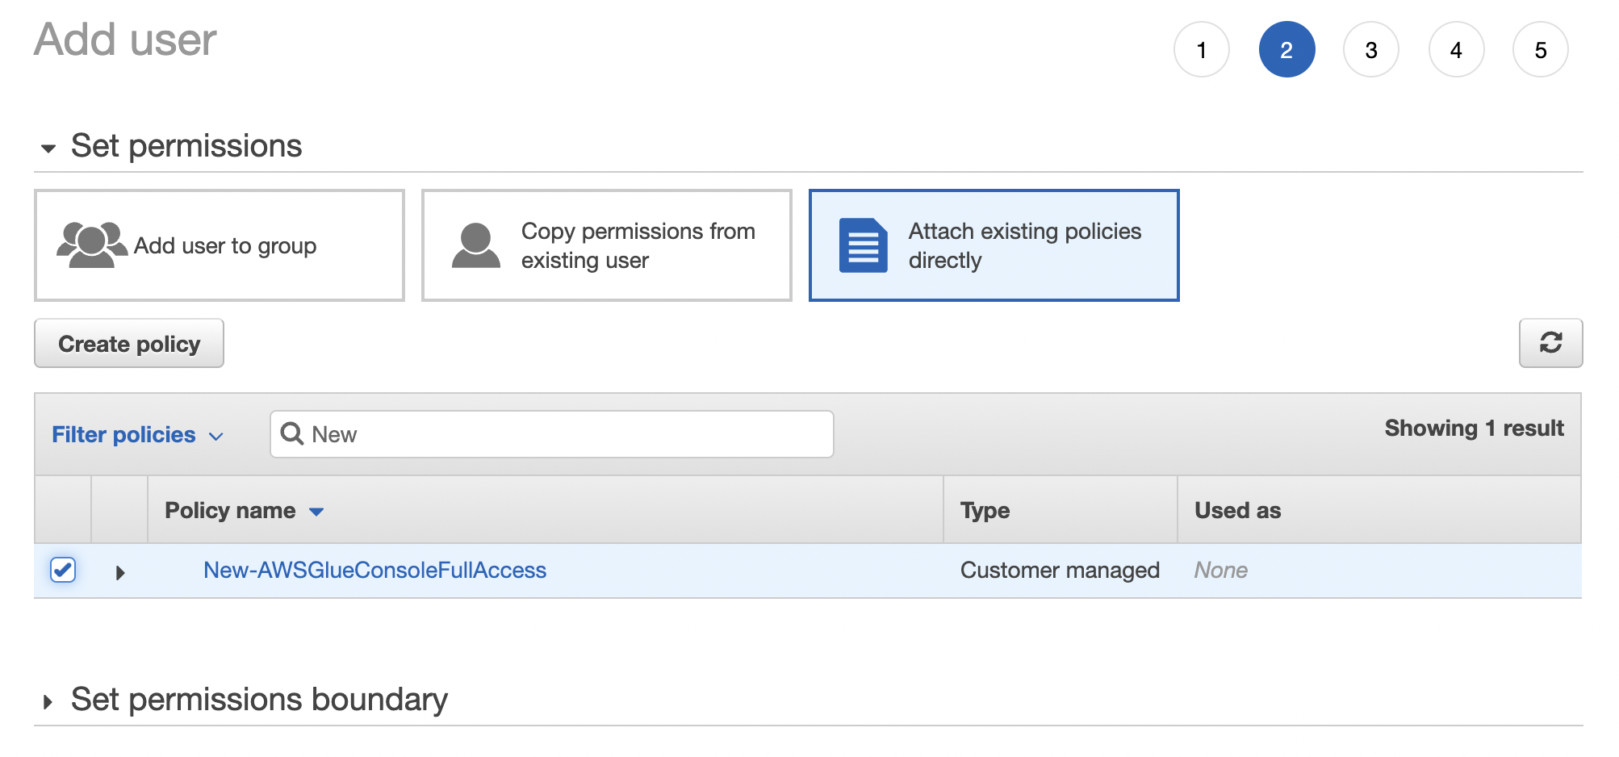

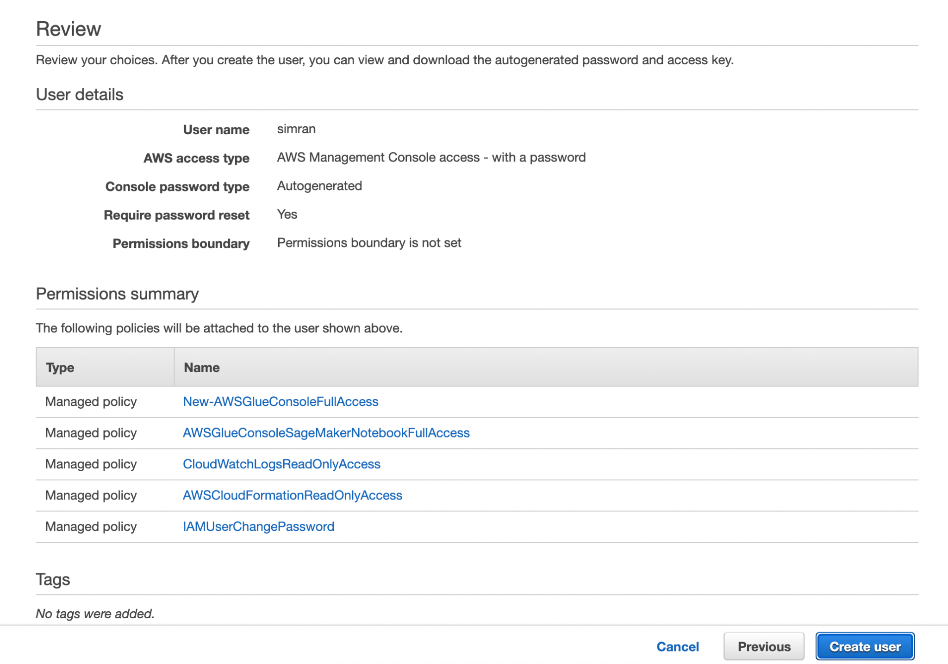



## Step 4: Create an IAM Policy for Notebook Servers

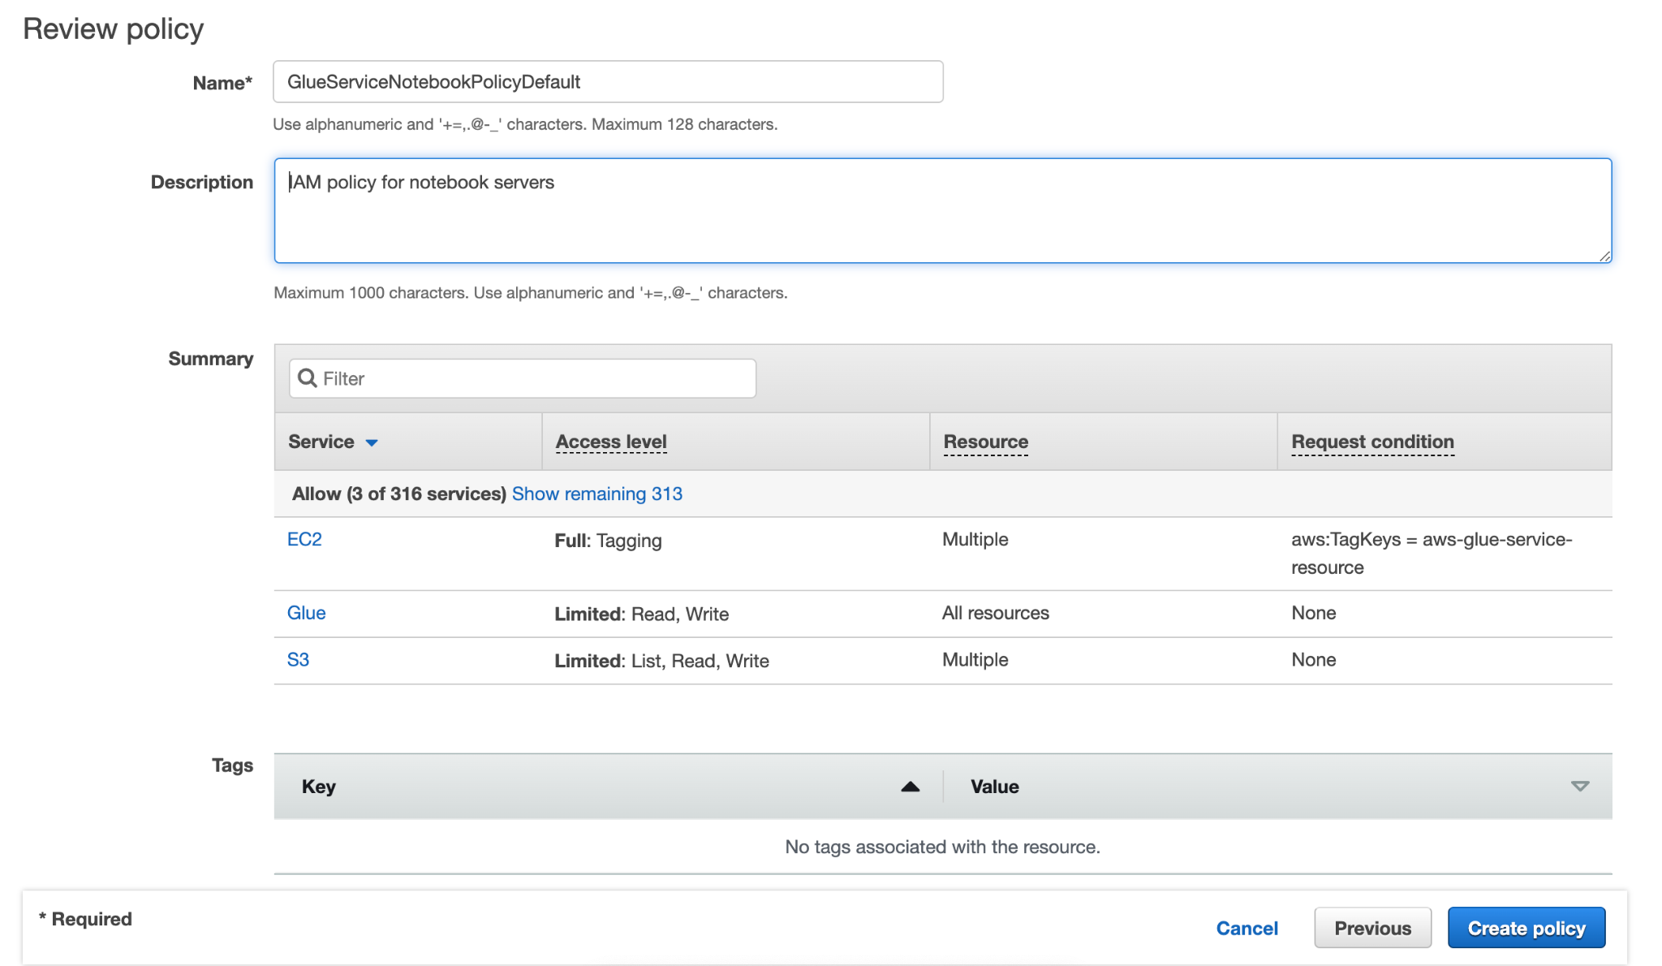



## Step 5: Create an IAM Role for Notebook Servers

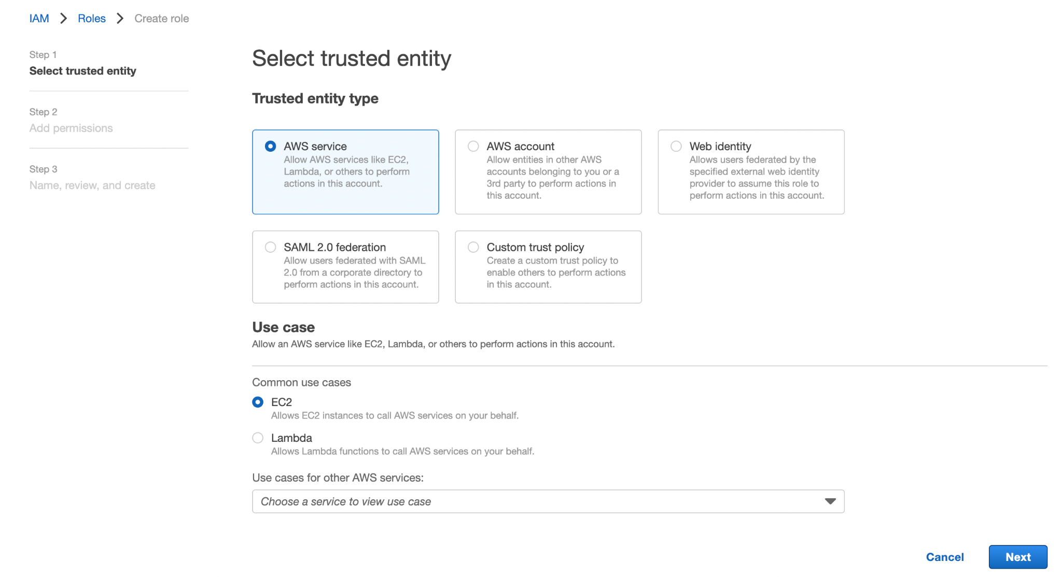

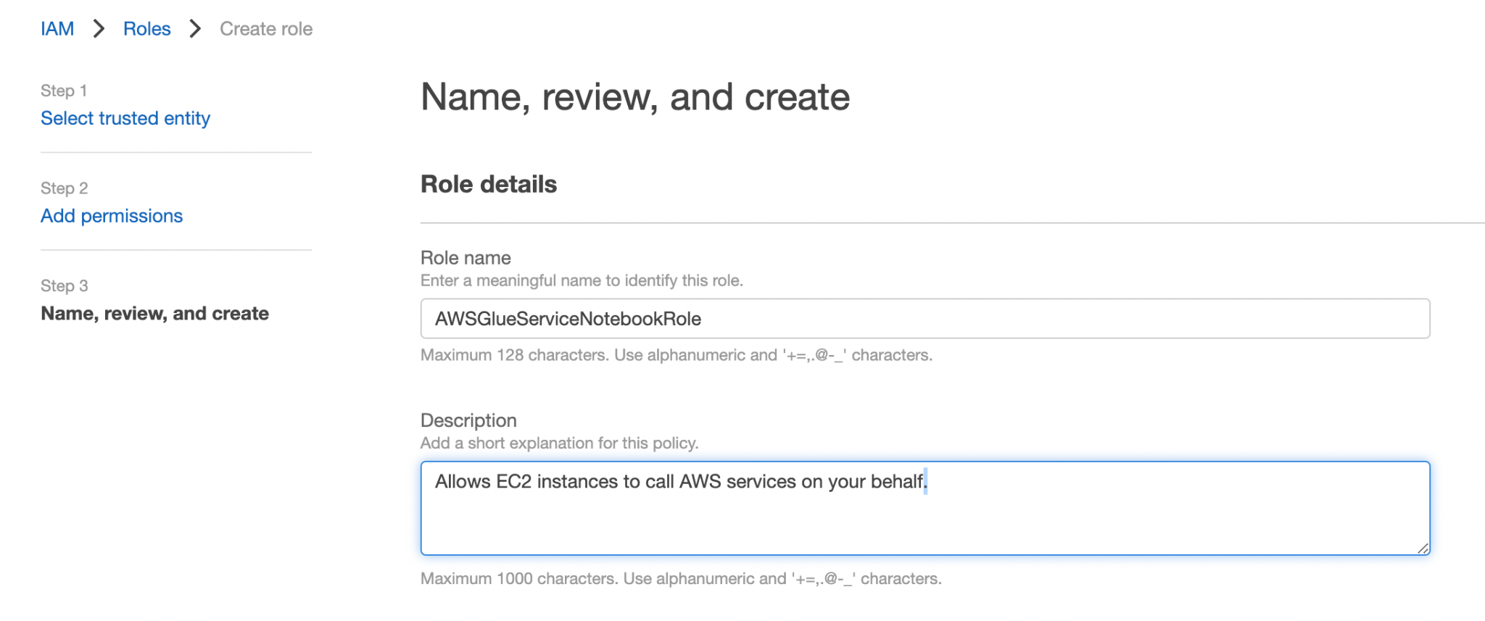



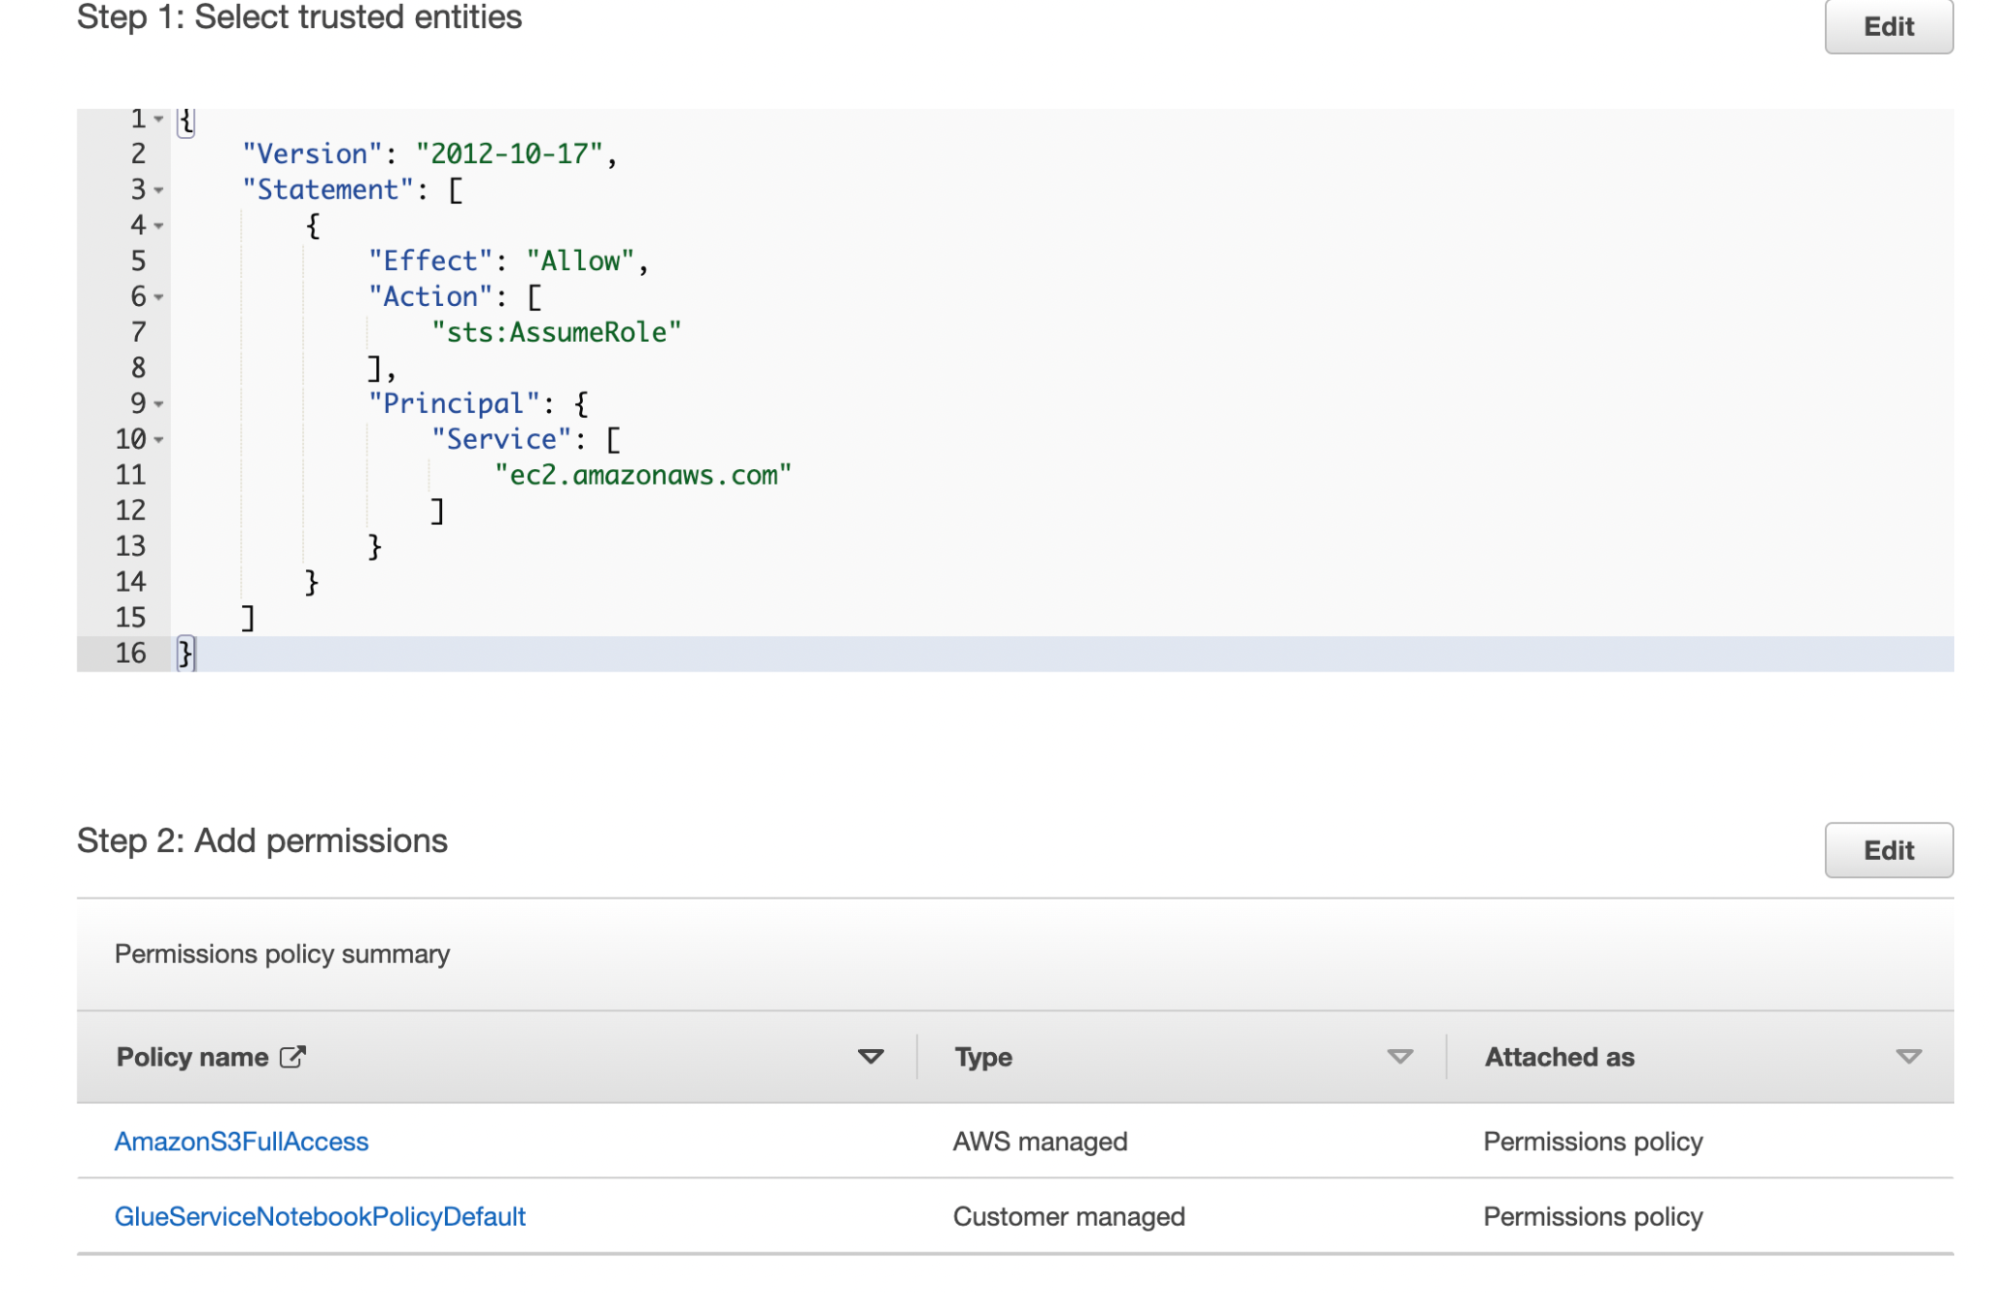

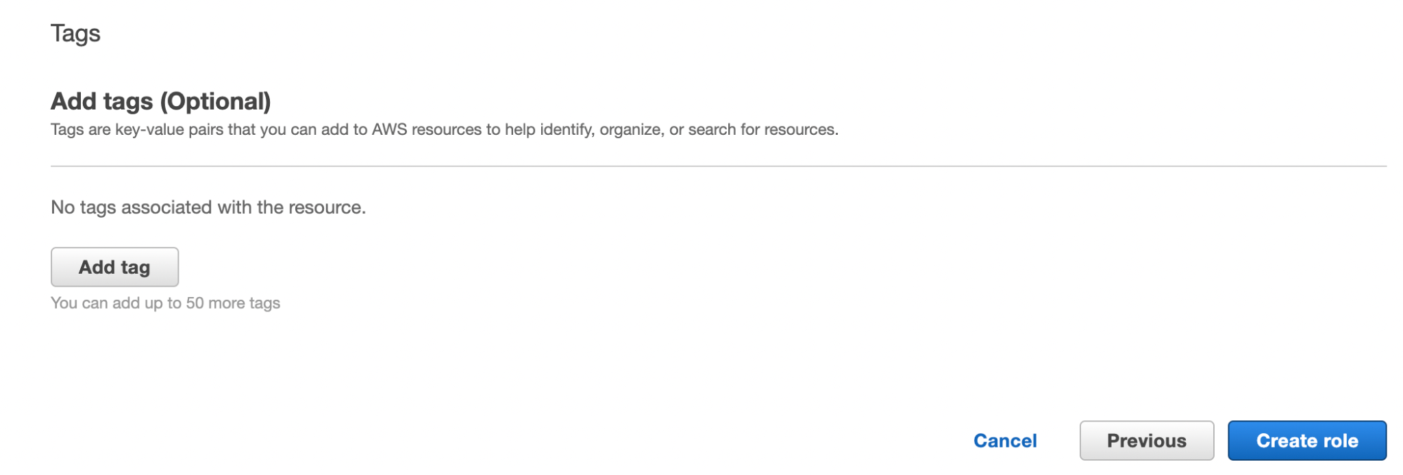

## Step 6: Create an IAM Policy for SageMaker Notebooks

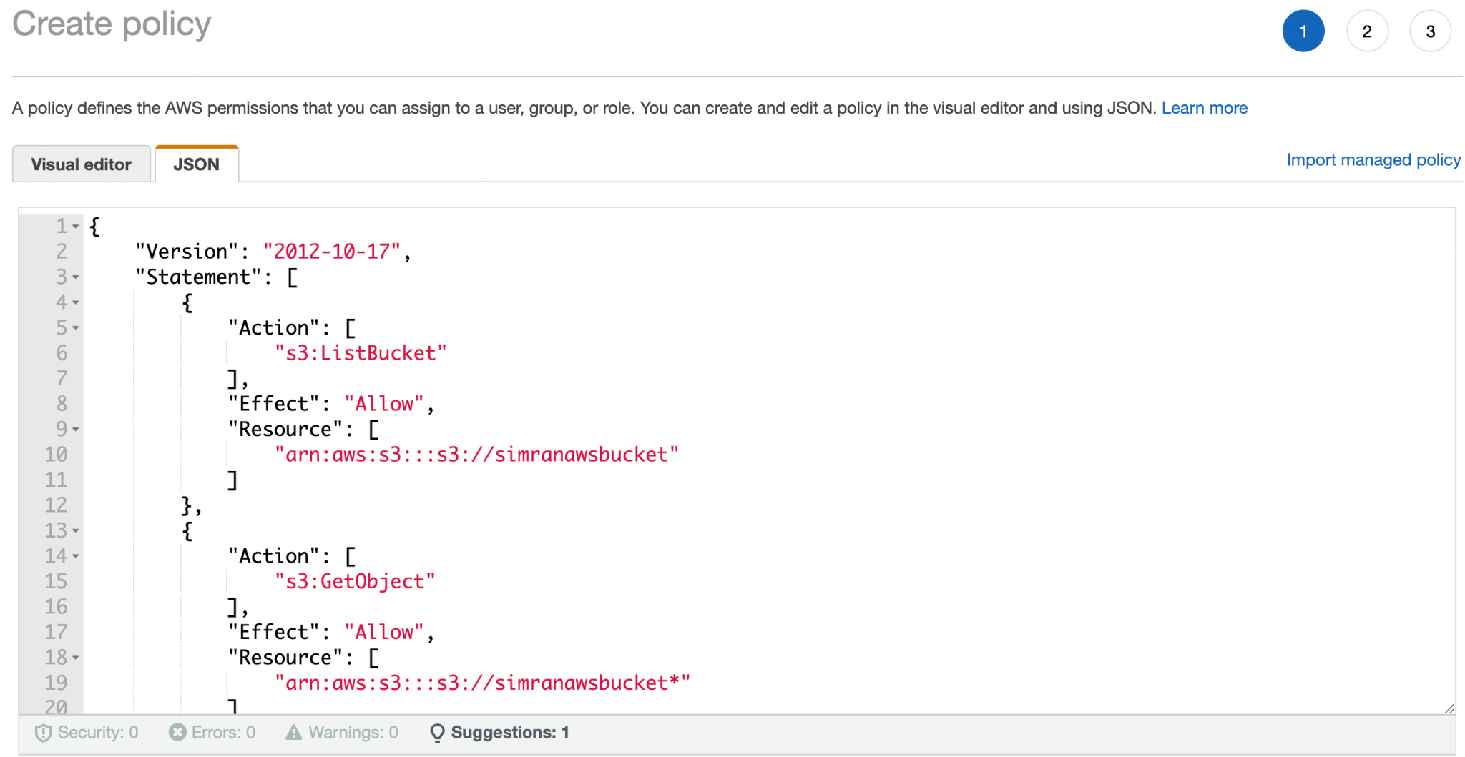

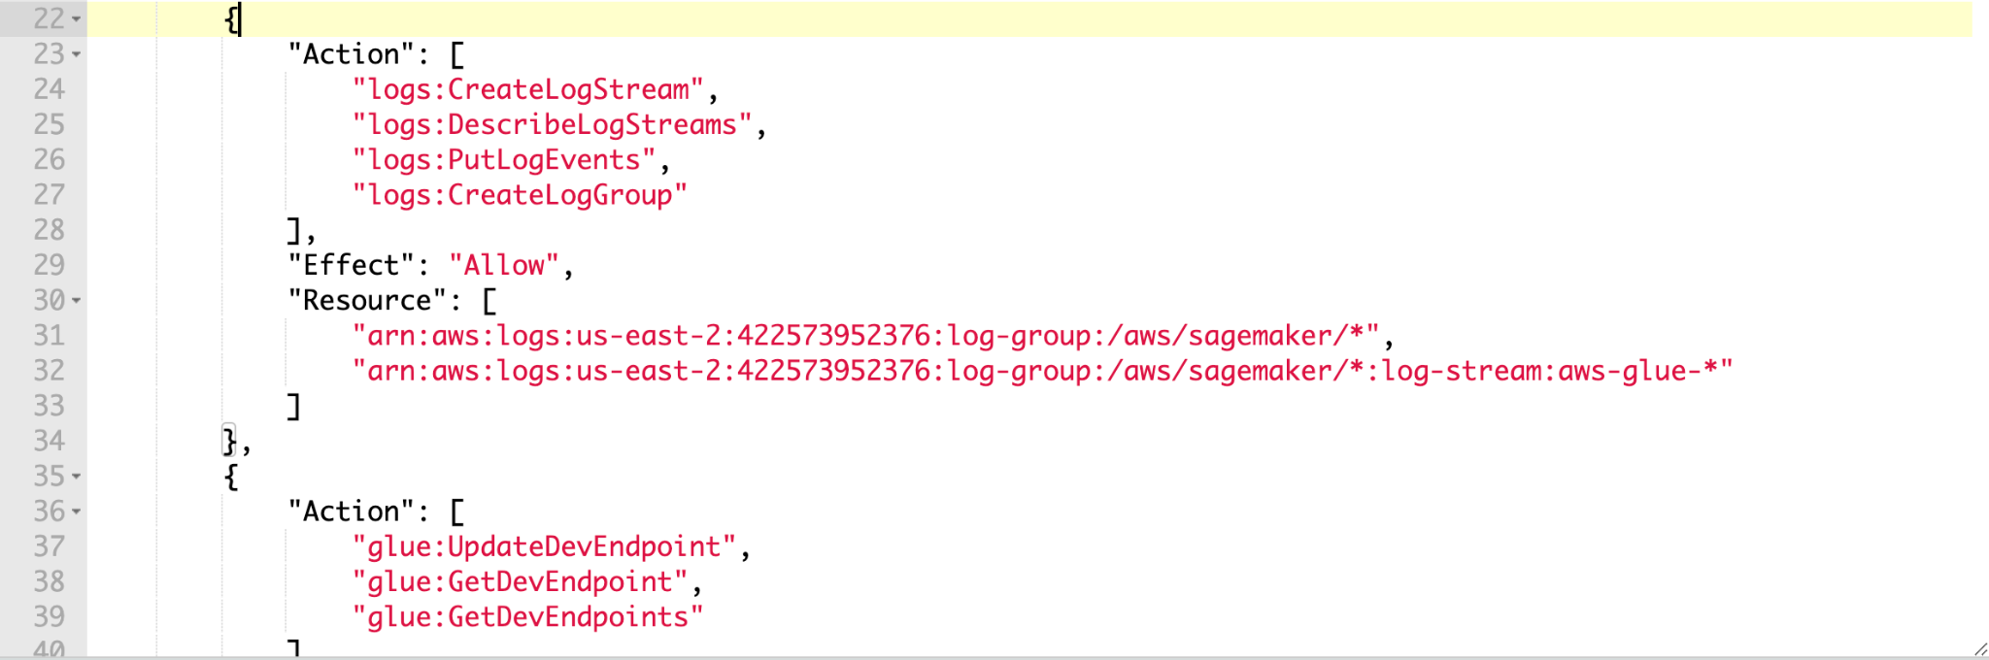

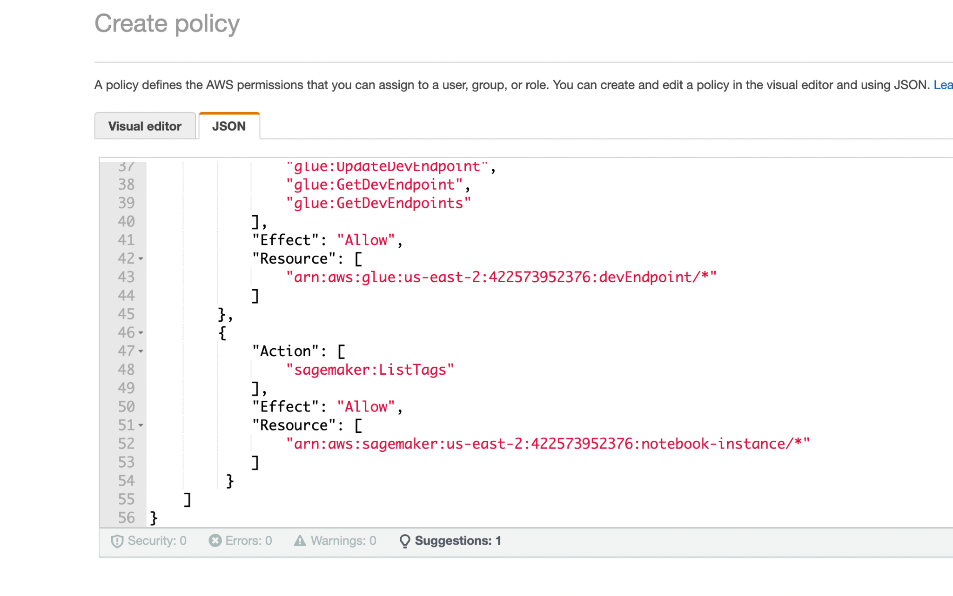

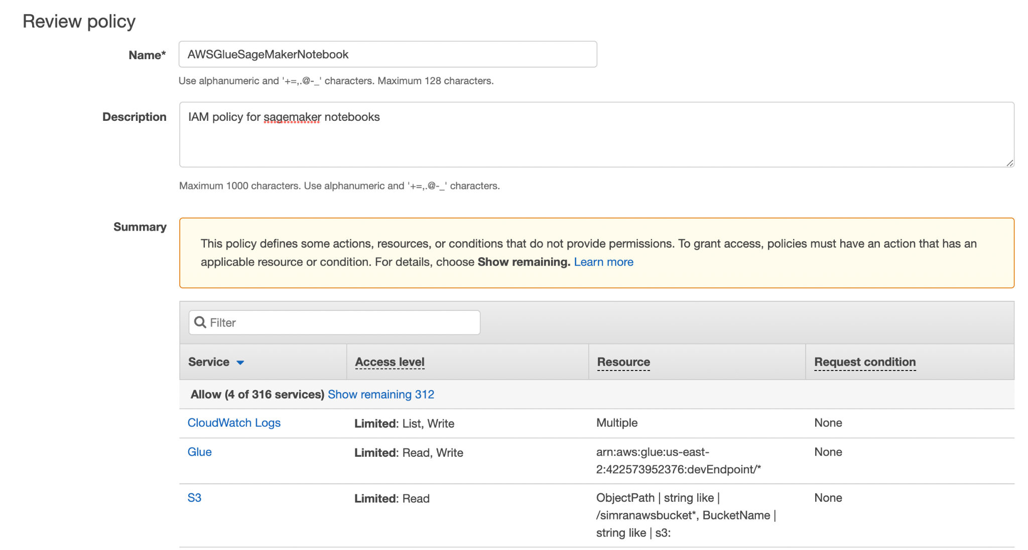

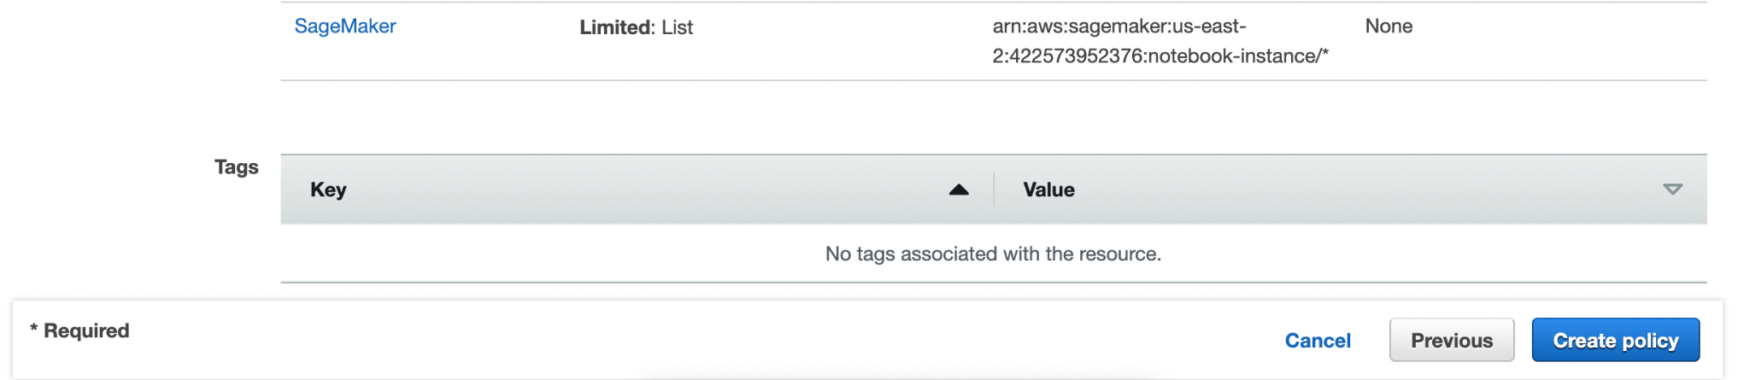



## Step 7: Create an IAM Role for SageMaker Notebooks

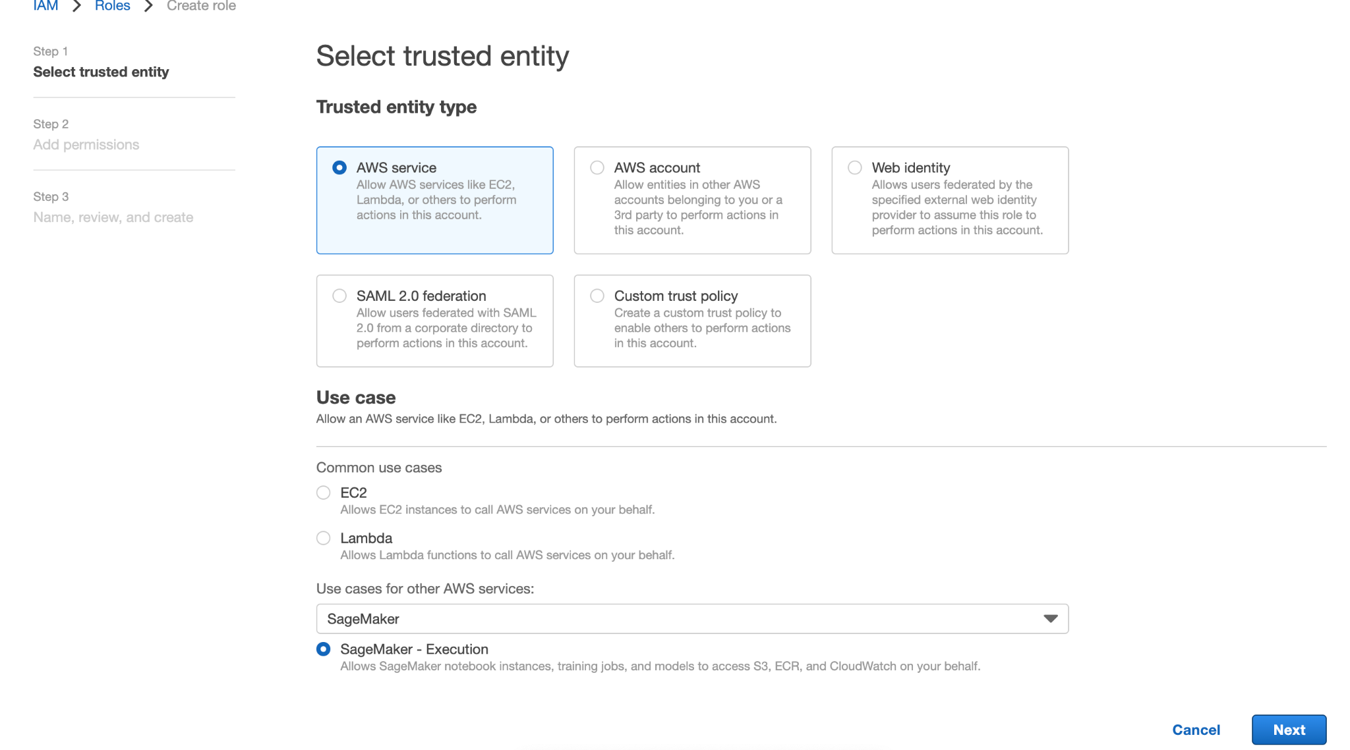

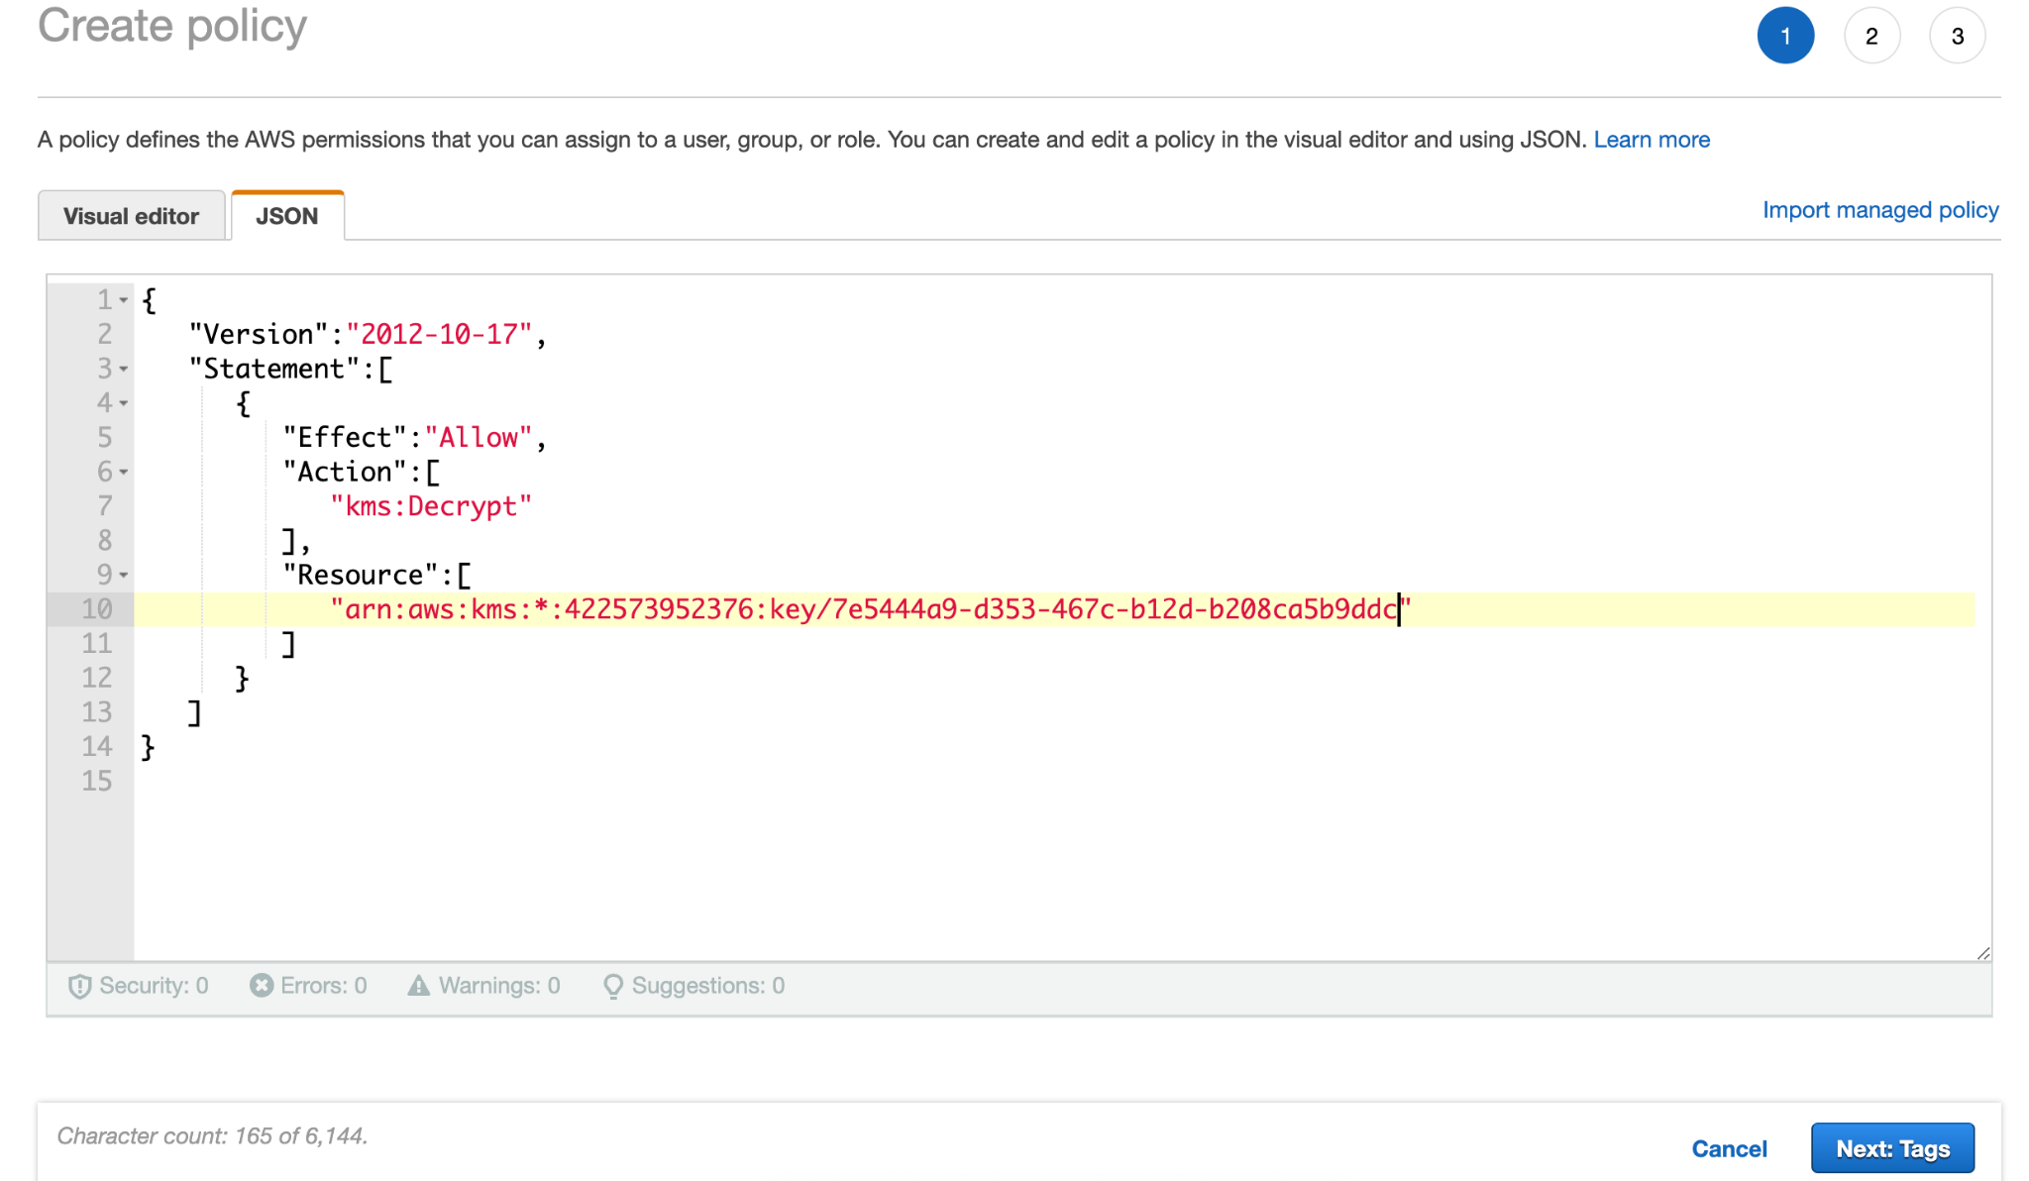

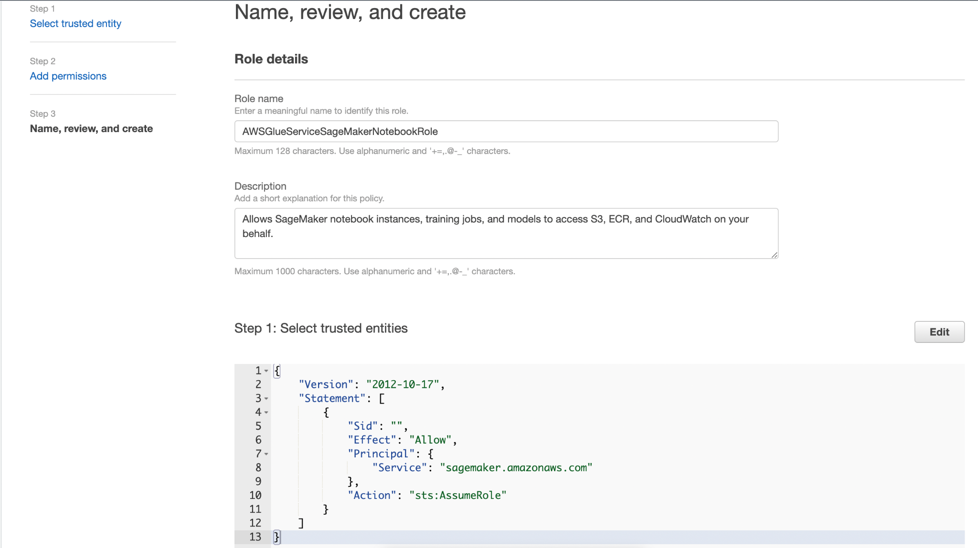

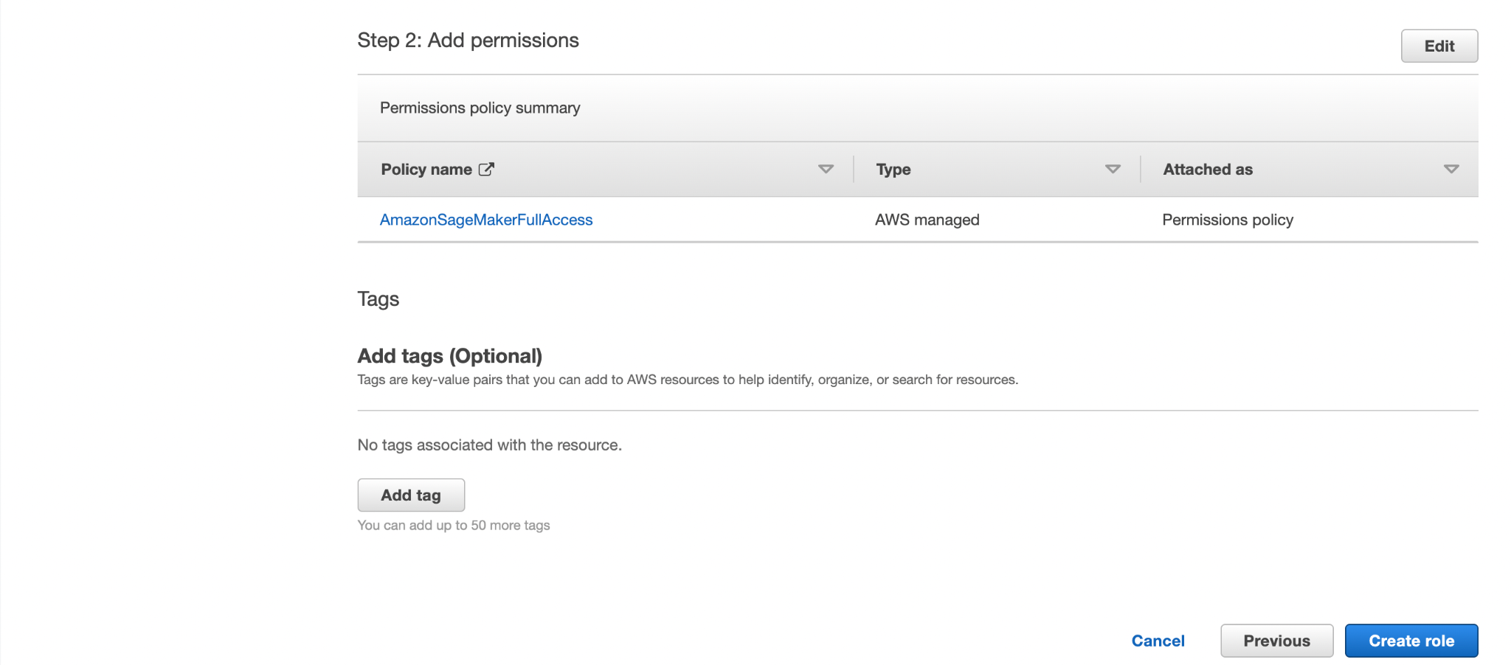



# Setting Up DNS in Your VPC

To configure DNS in your VPC,

* DNS hostnames and DNS resolution should be enabled in the VPC.
* The VPC network attributes ***enableDnsHostnames*** and ***enableDnsSupport*** must be set to true.

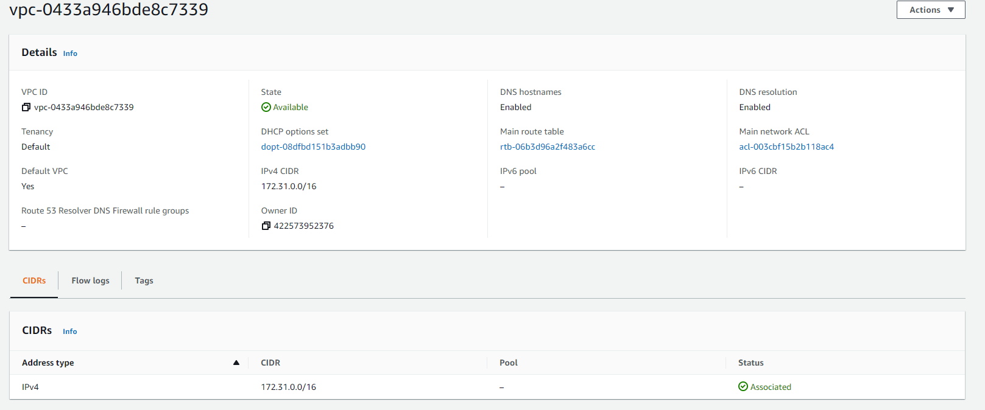

# Setting Up Your Environment to Access Data Stores

## Amazon VPC Endpoints for Amazon S3

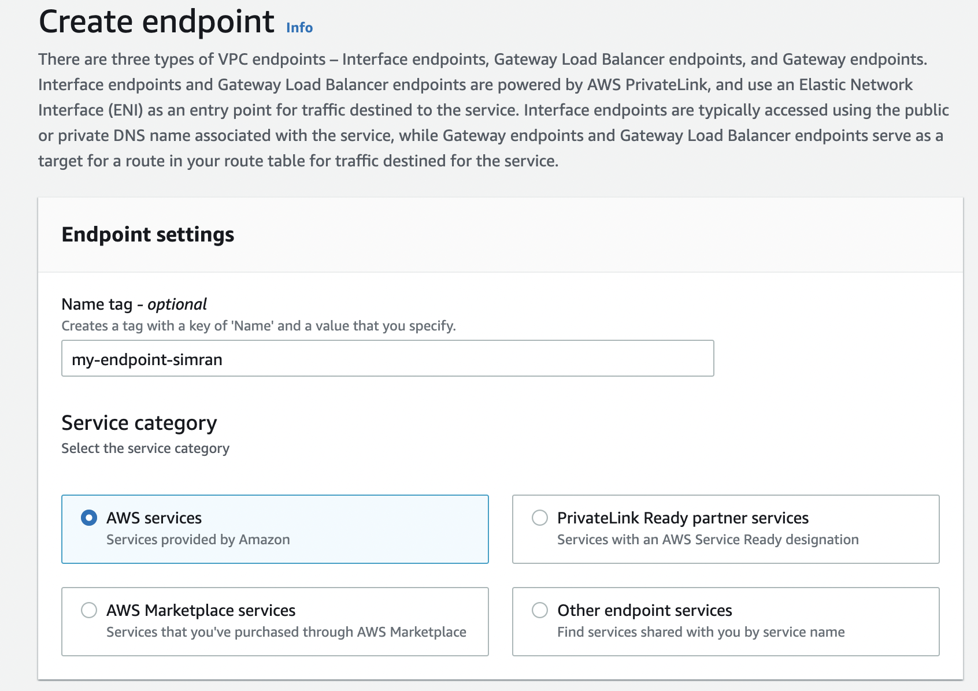

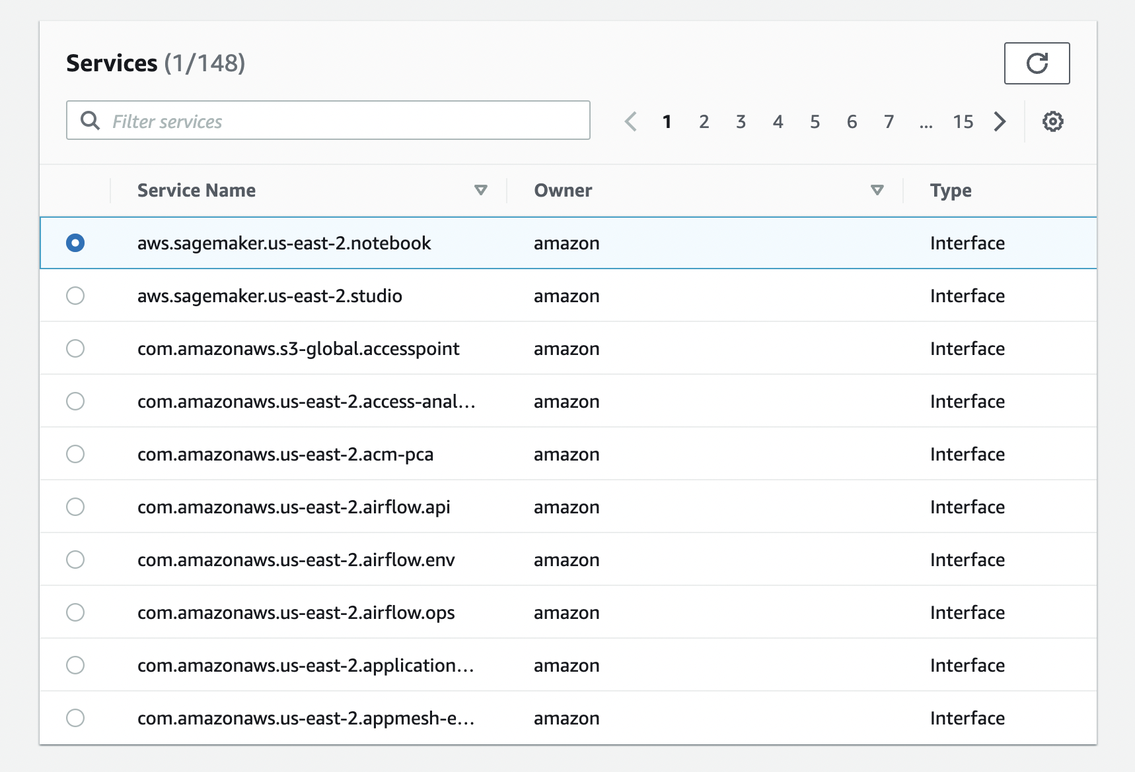

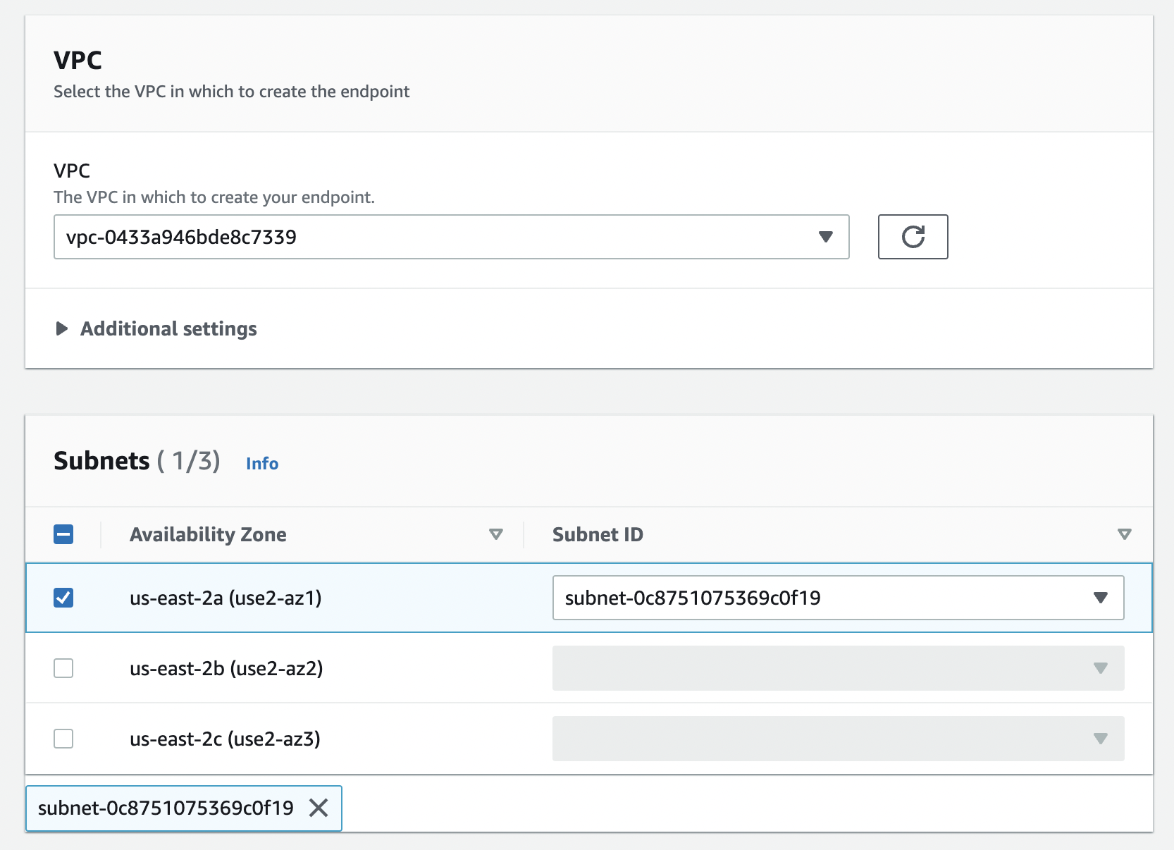

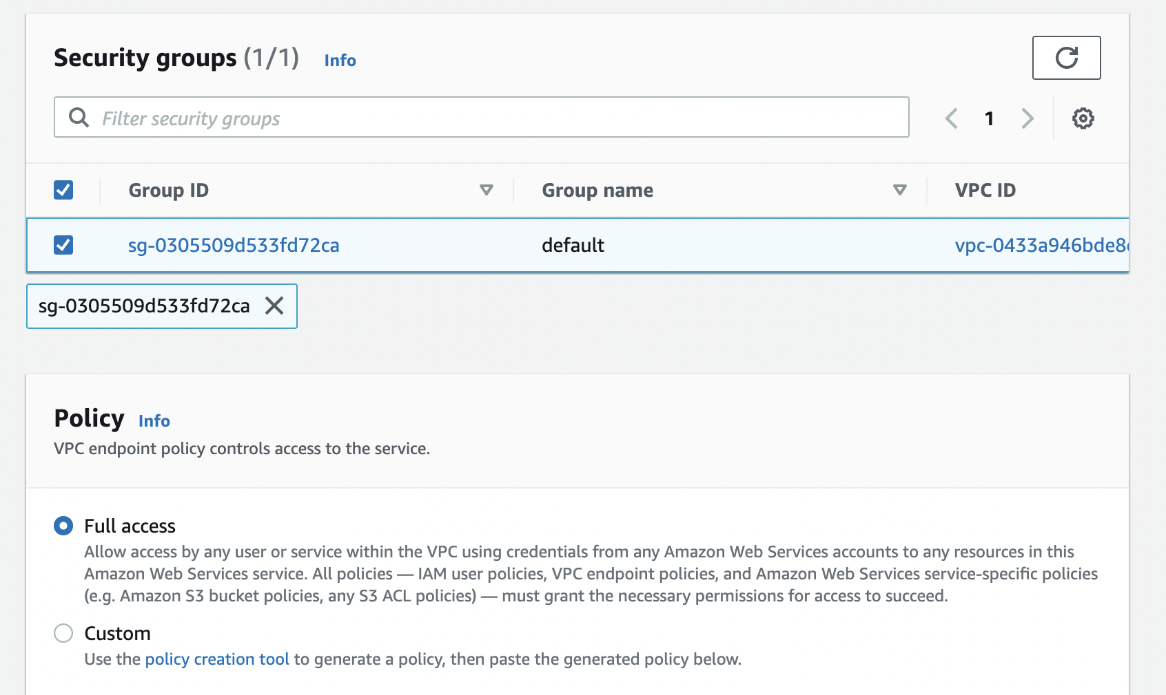



## Setting Up a VPC to Connect to JDBC Data Stores

### Set up access for Amazon Redshift data stores



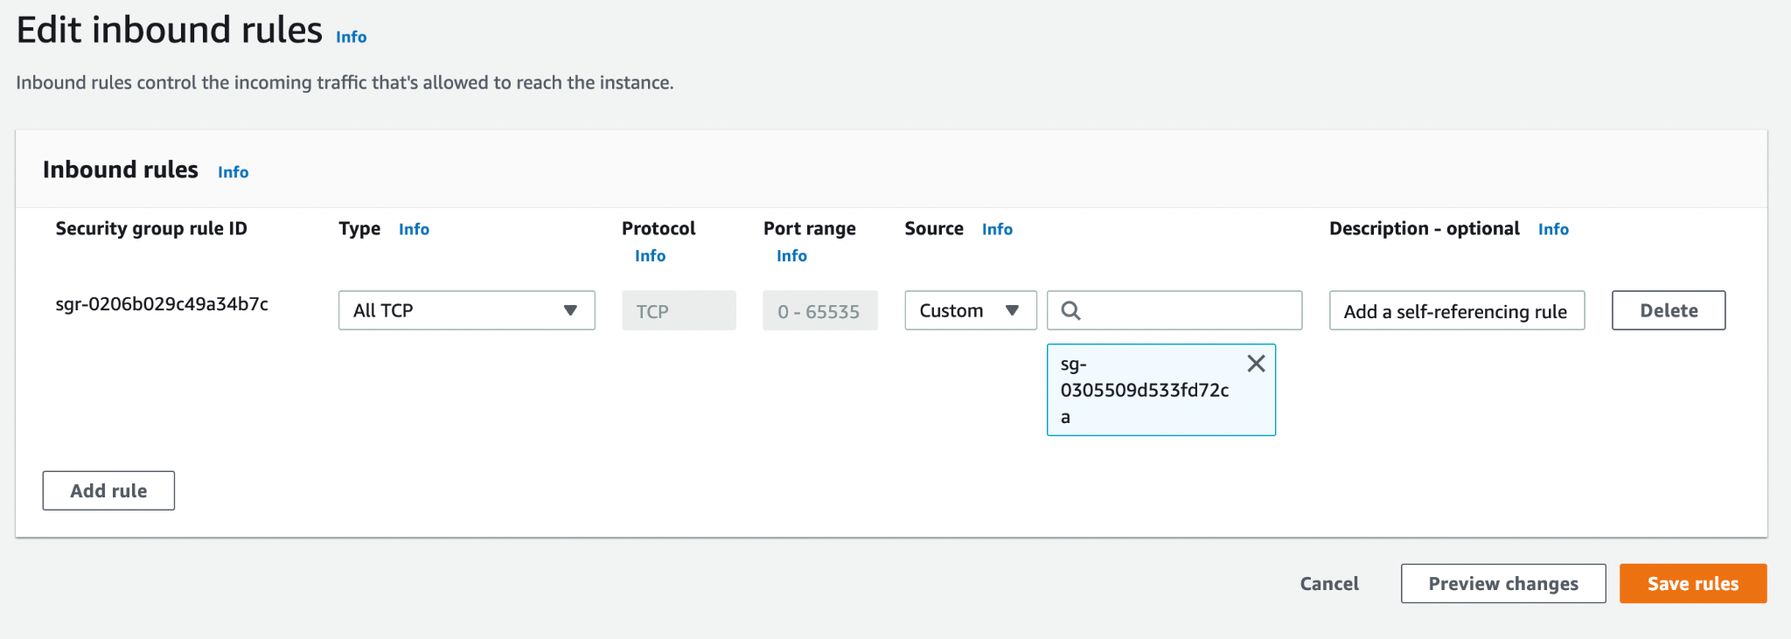

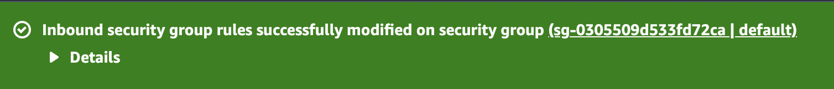

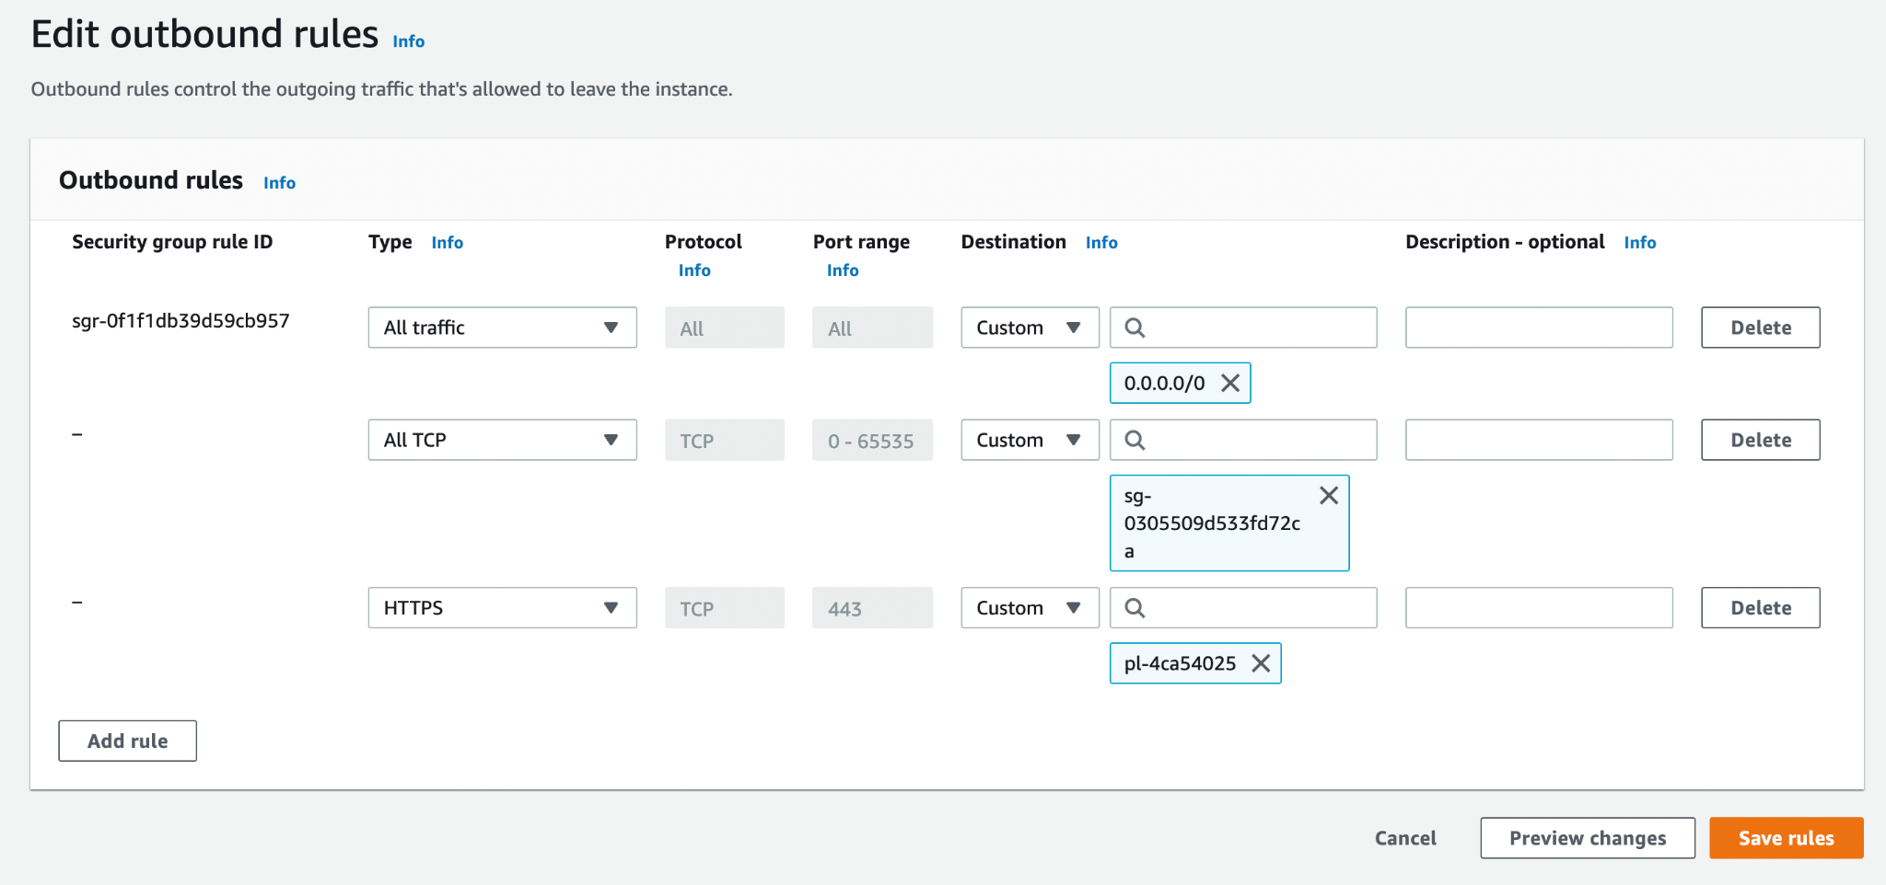

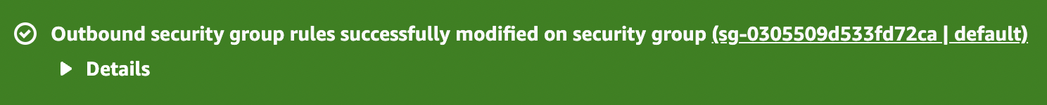

### Set up access for Amazon RDS data stores

Amazon RDS Engine

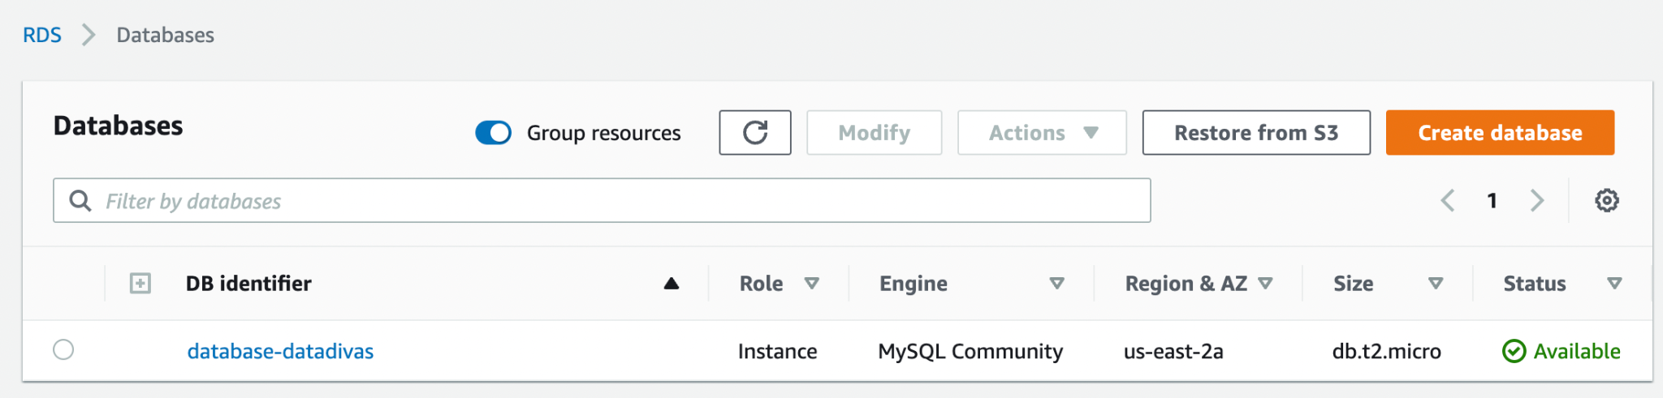

Security Groups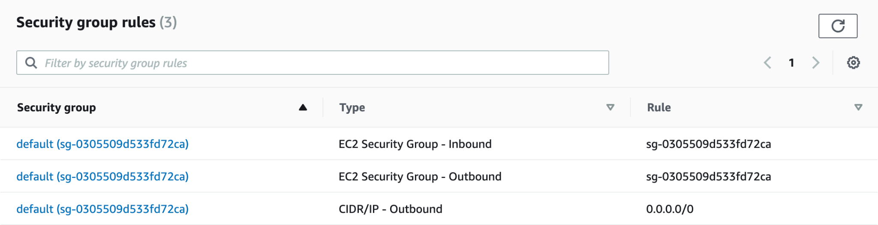

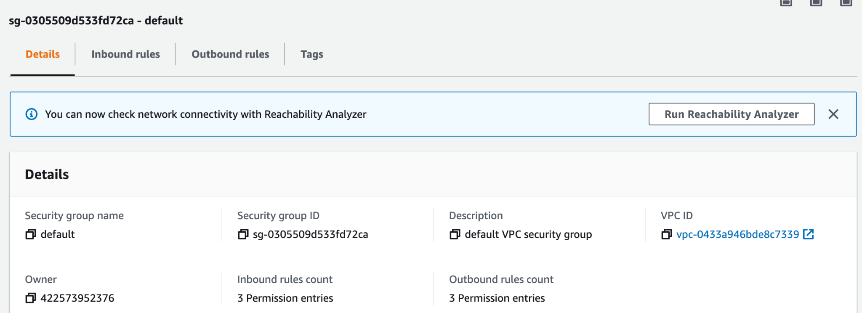

Inbound Rules

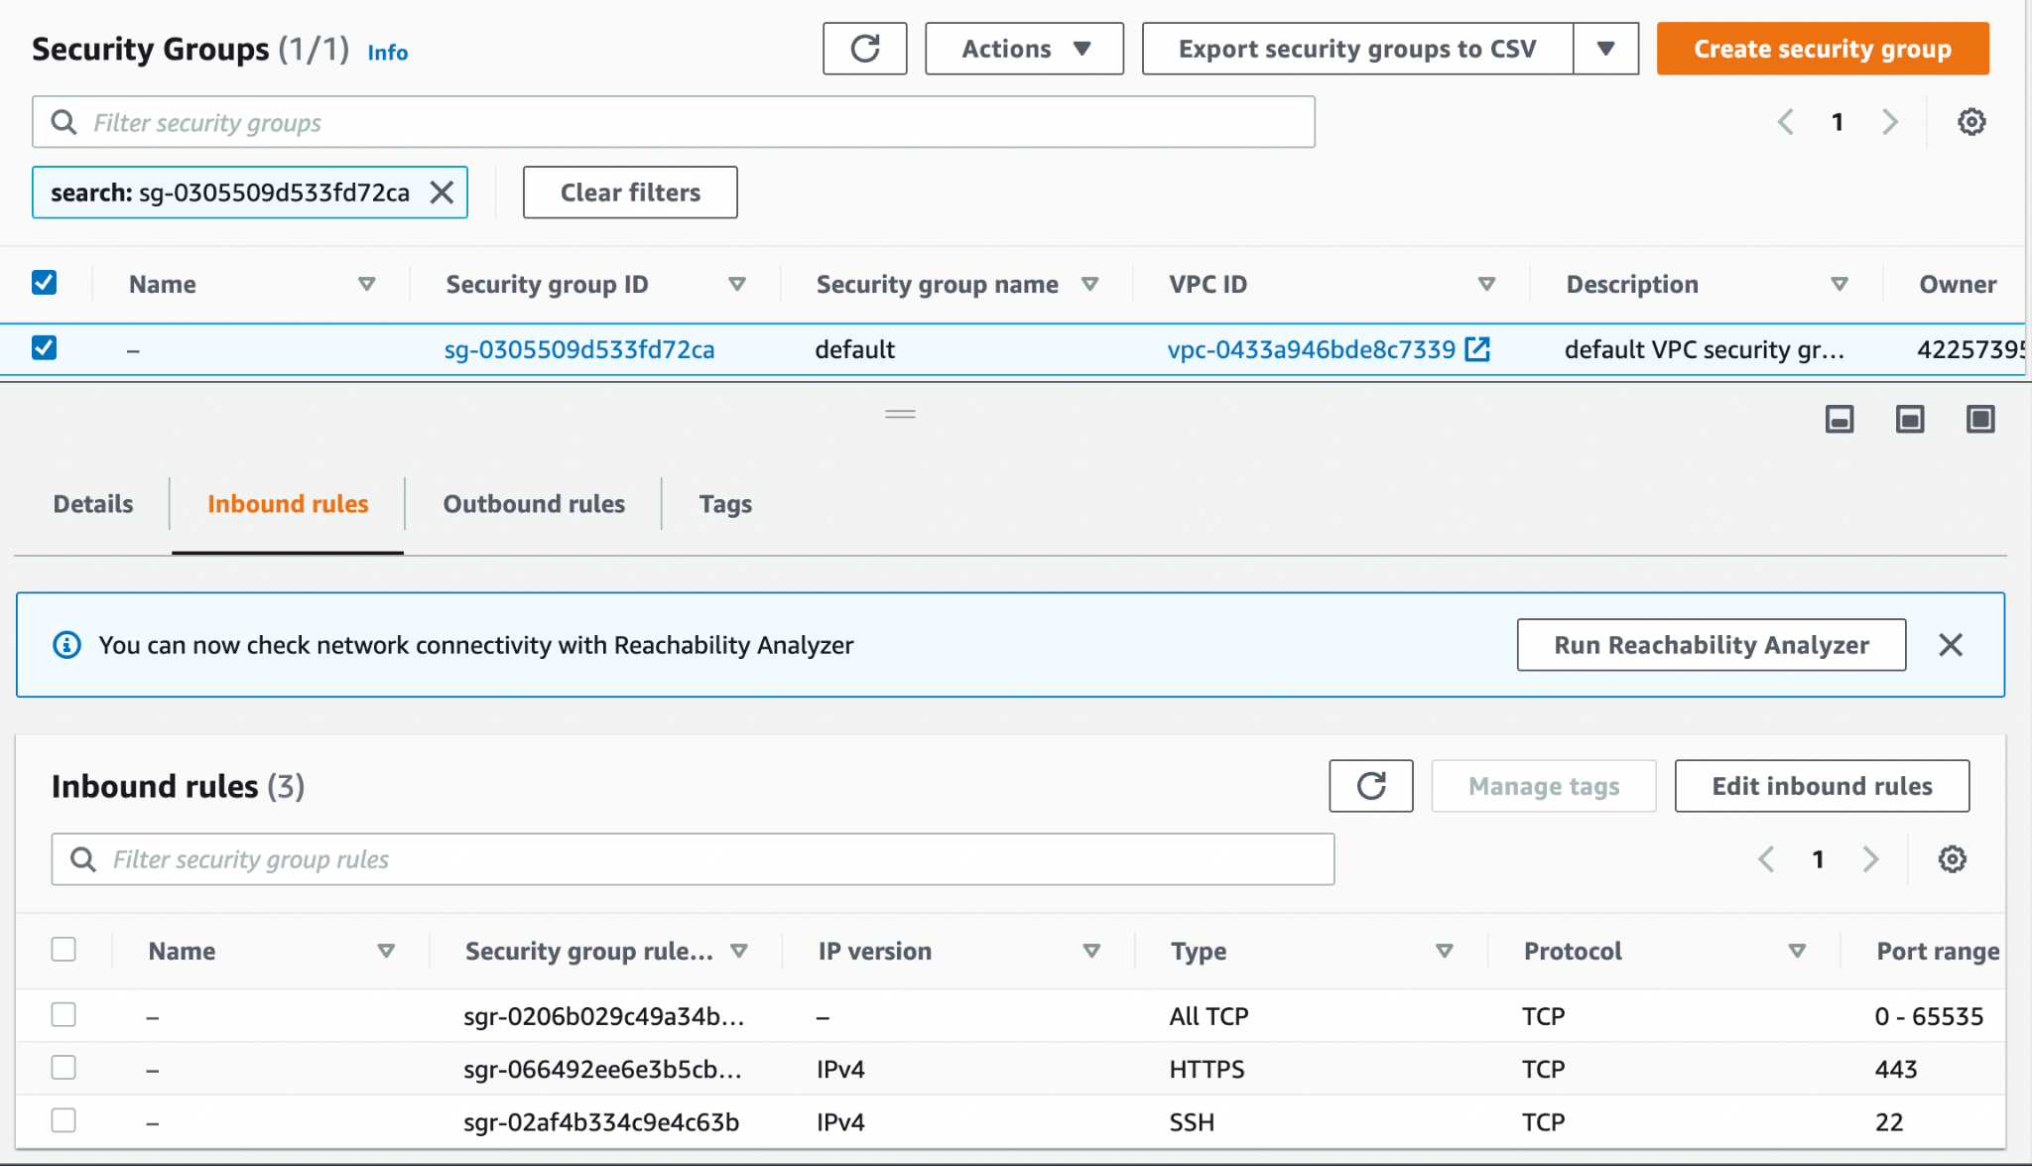

Outbound Rules

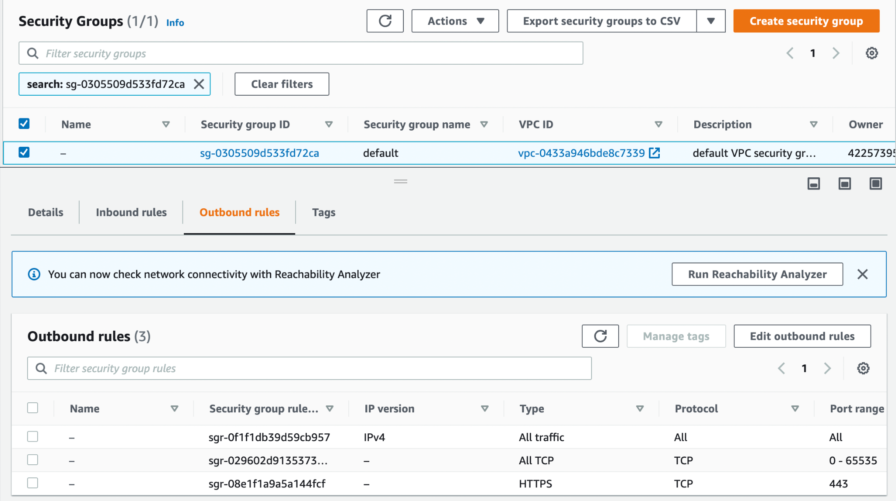

# Setting Up Your Environment for Development Endpoints

## Setting Up Your Network for a Development Endpoint

Create security group

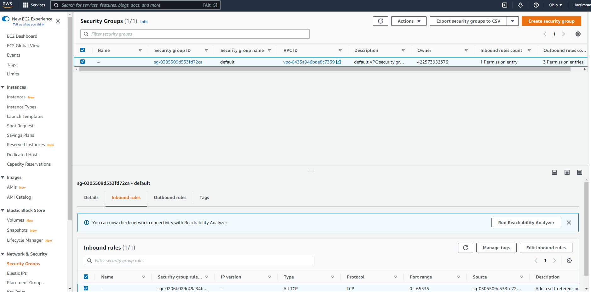

Set inbound rules

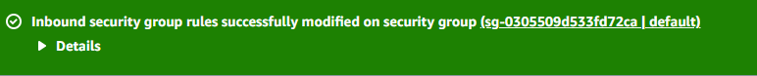

Set outbound rules

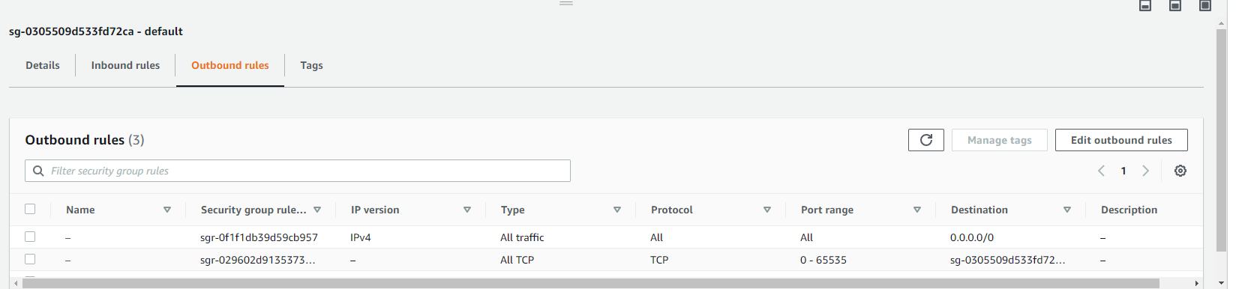

## Setting Up Amazon EC2 for a Notebook Server



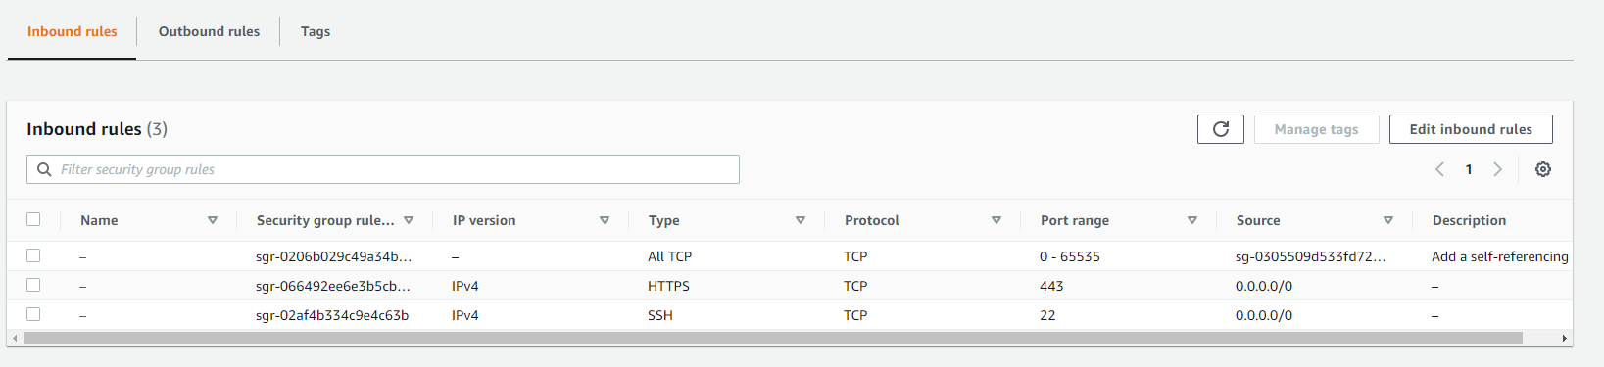

# Setting Up Encryption in AWS Glue

1. Added the required permissions policy in AWS Glue console policy:

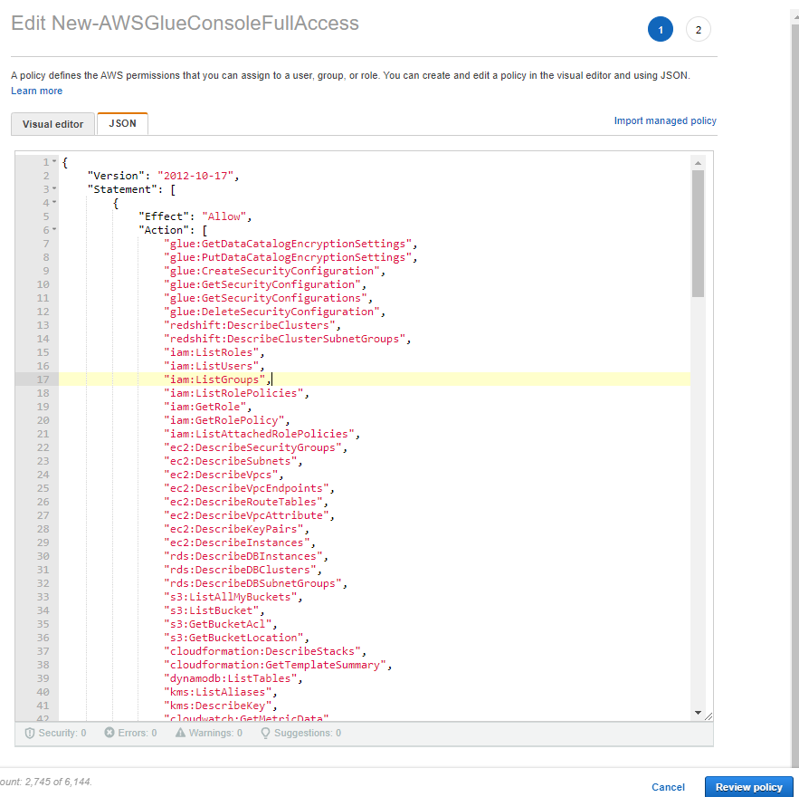

1. On the AWS Glue console, choose **Settings** in the navigation pane.

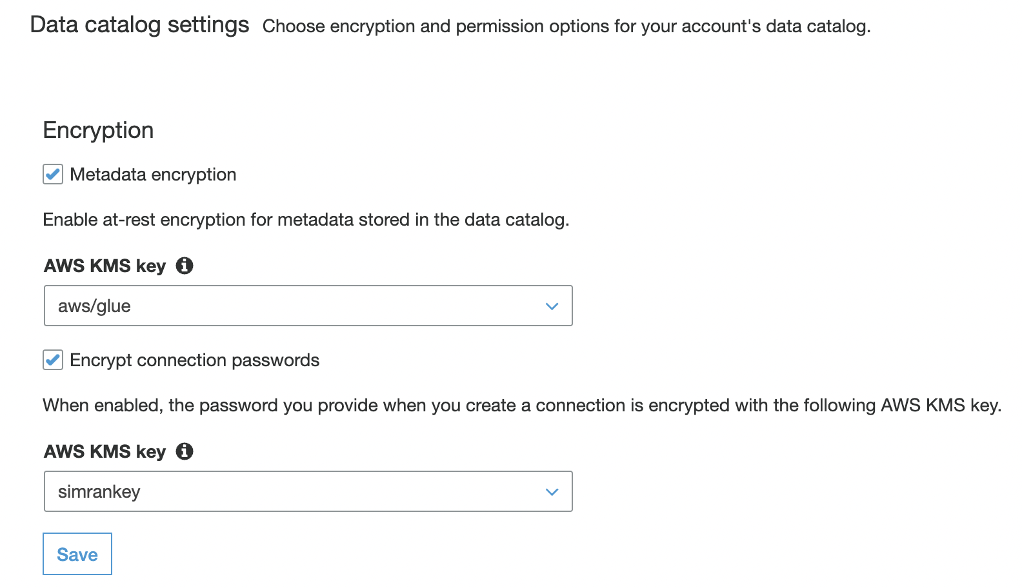

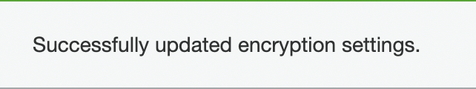

1. Security configuration

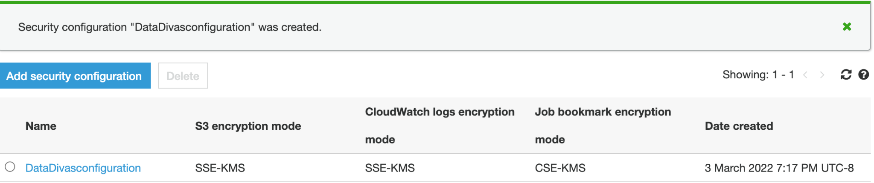

1. Create Database and click create.

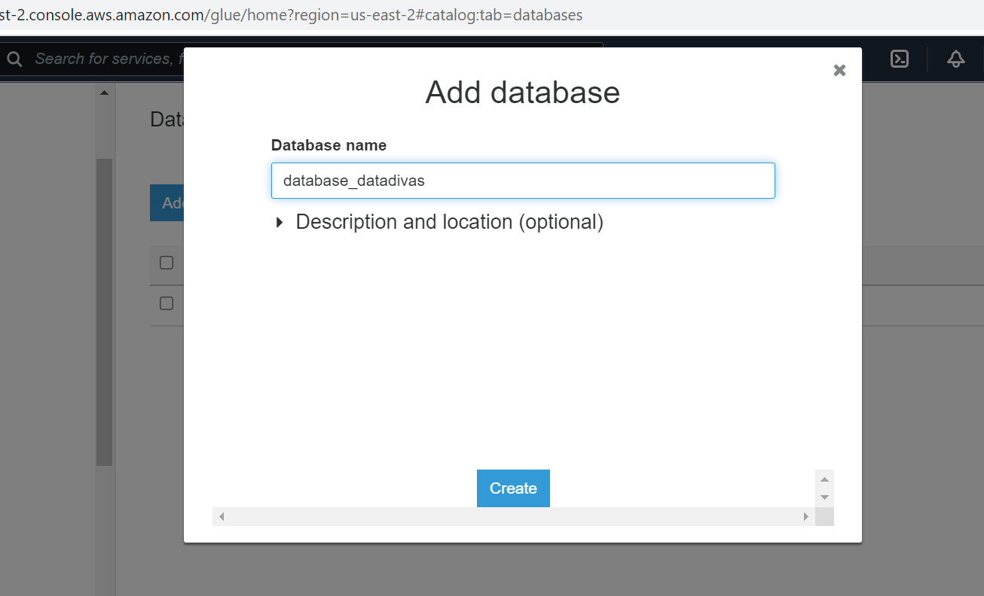

1. Add a table to the database. Select Add table manually option from drop-down menu.

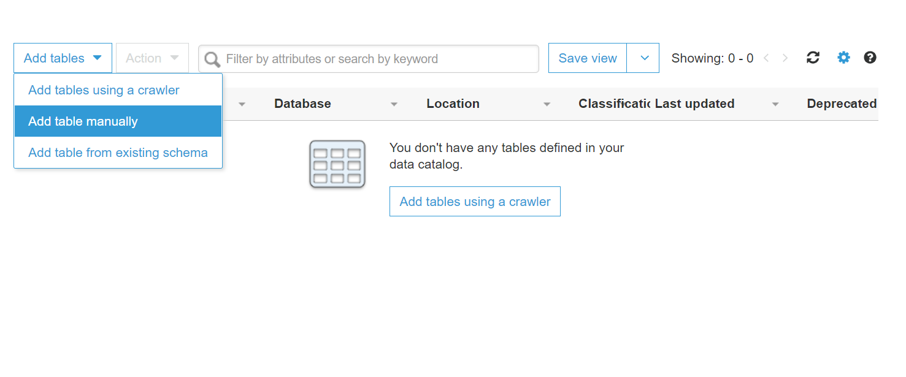

1. Enter the table name and select your database.

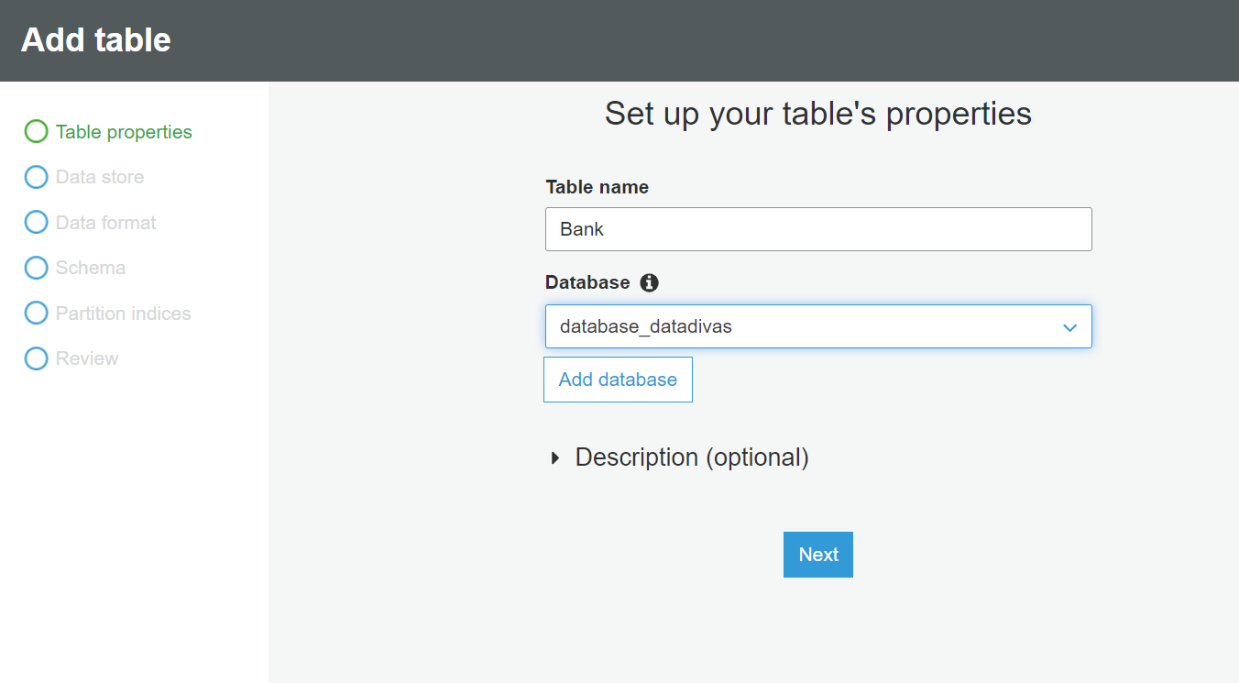

1. Select your s3 bucket

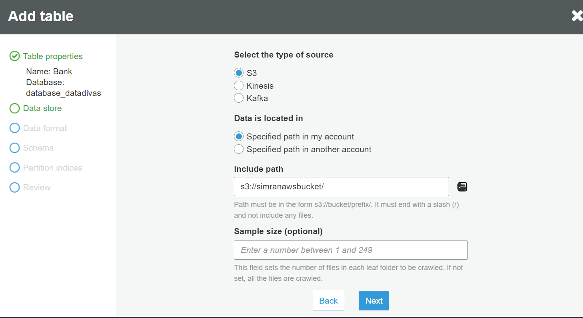

1. Next, choose a data format and delimiter and Press Next.

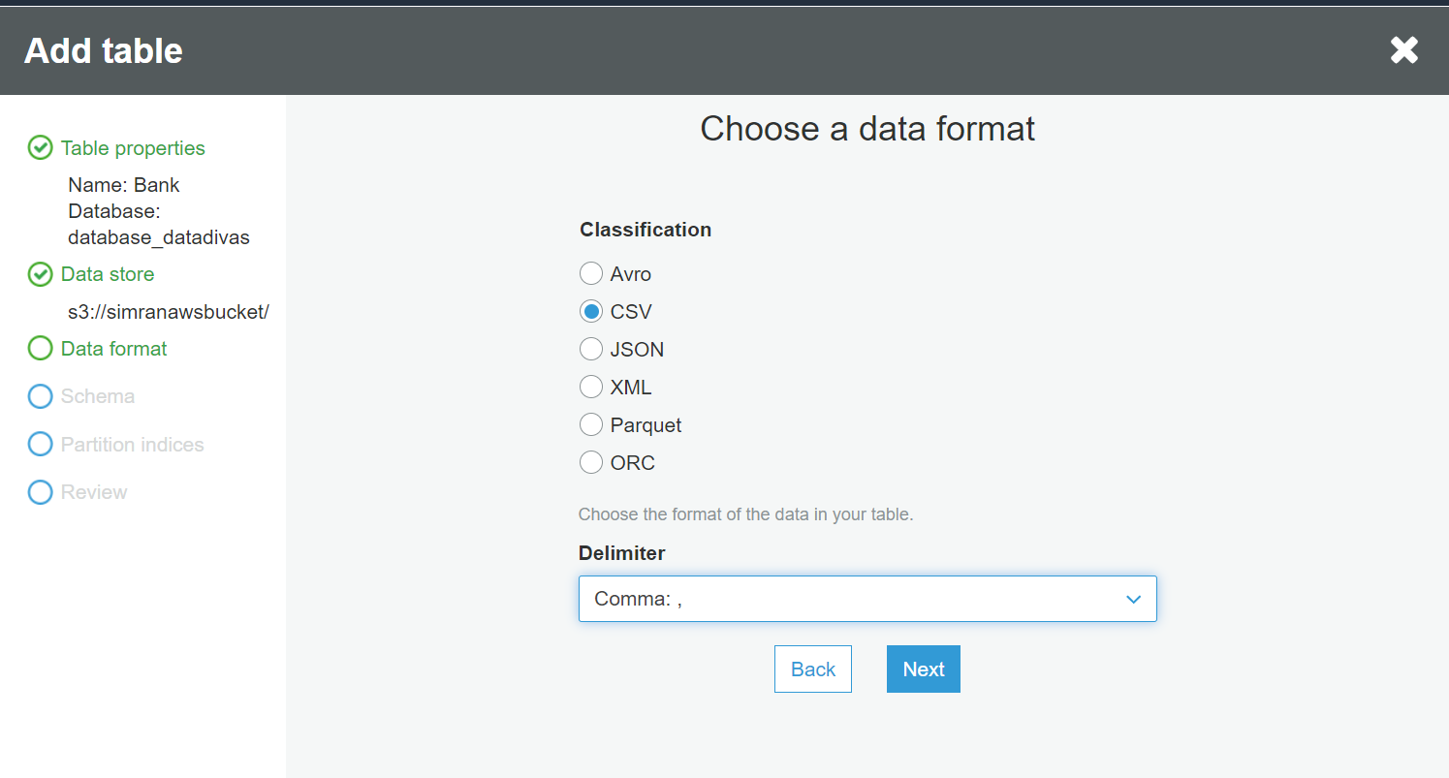

1. Click Add column to add a column of table manually.

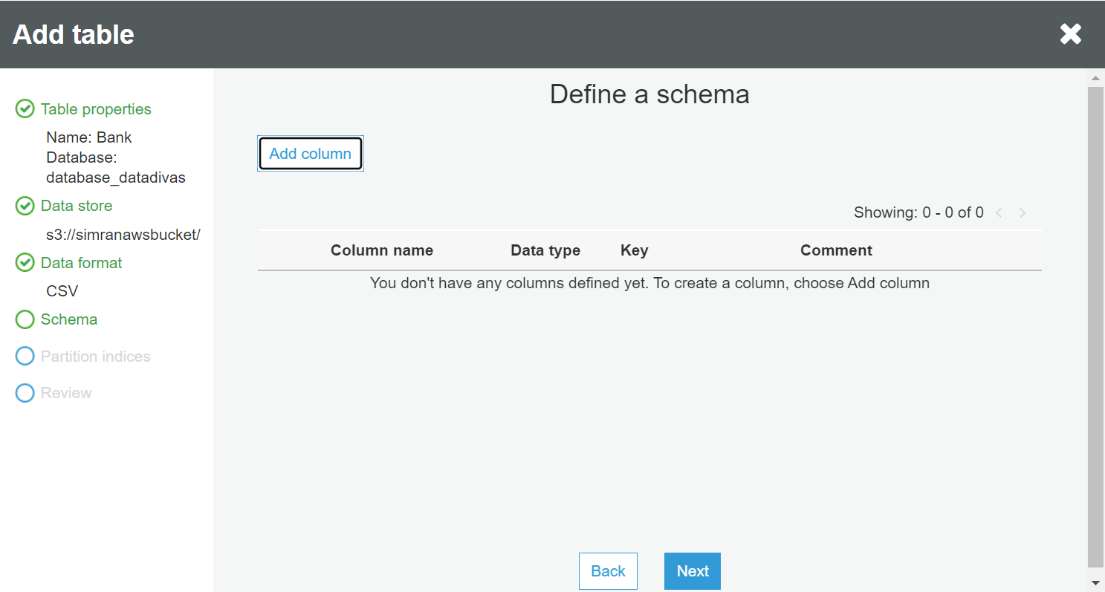

1. Add column name, select column type, and press Add.

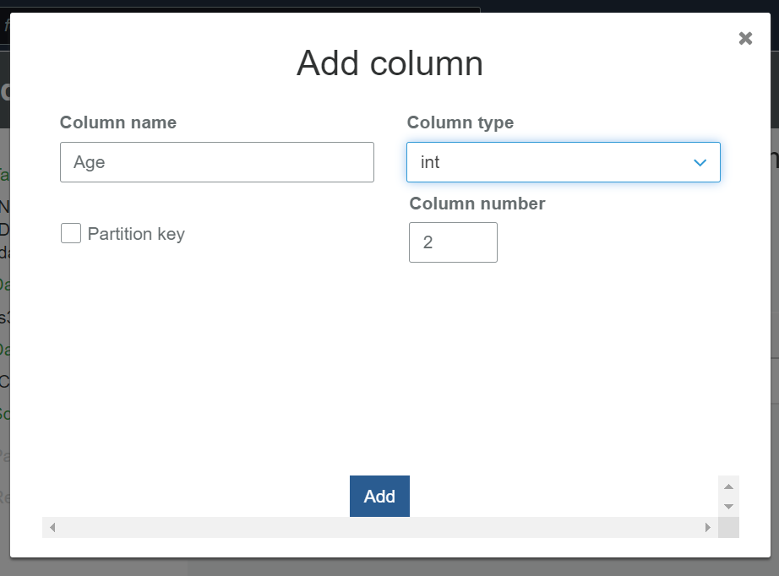

1. Press Next.

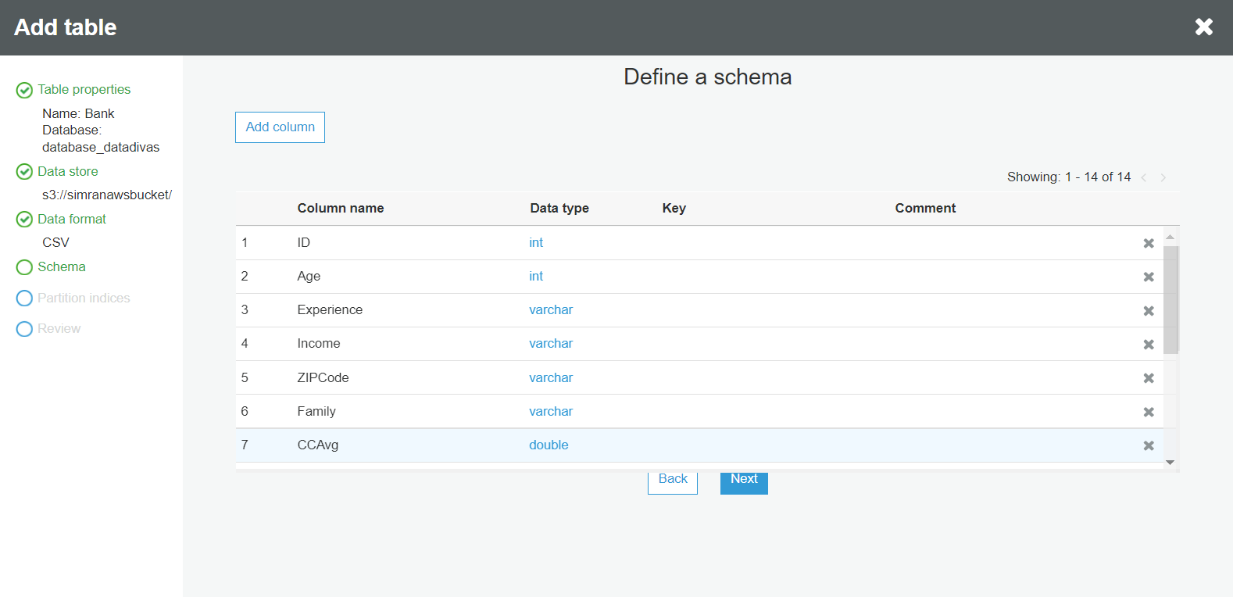

1. Select Partition indices (it’s Optional).

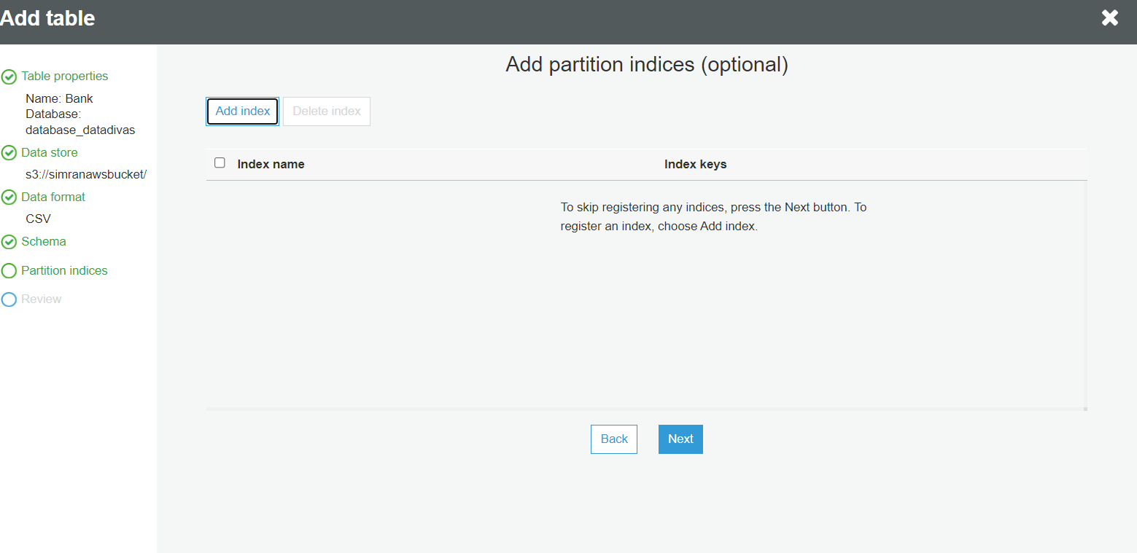

1. Final Review and Press Finish.

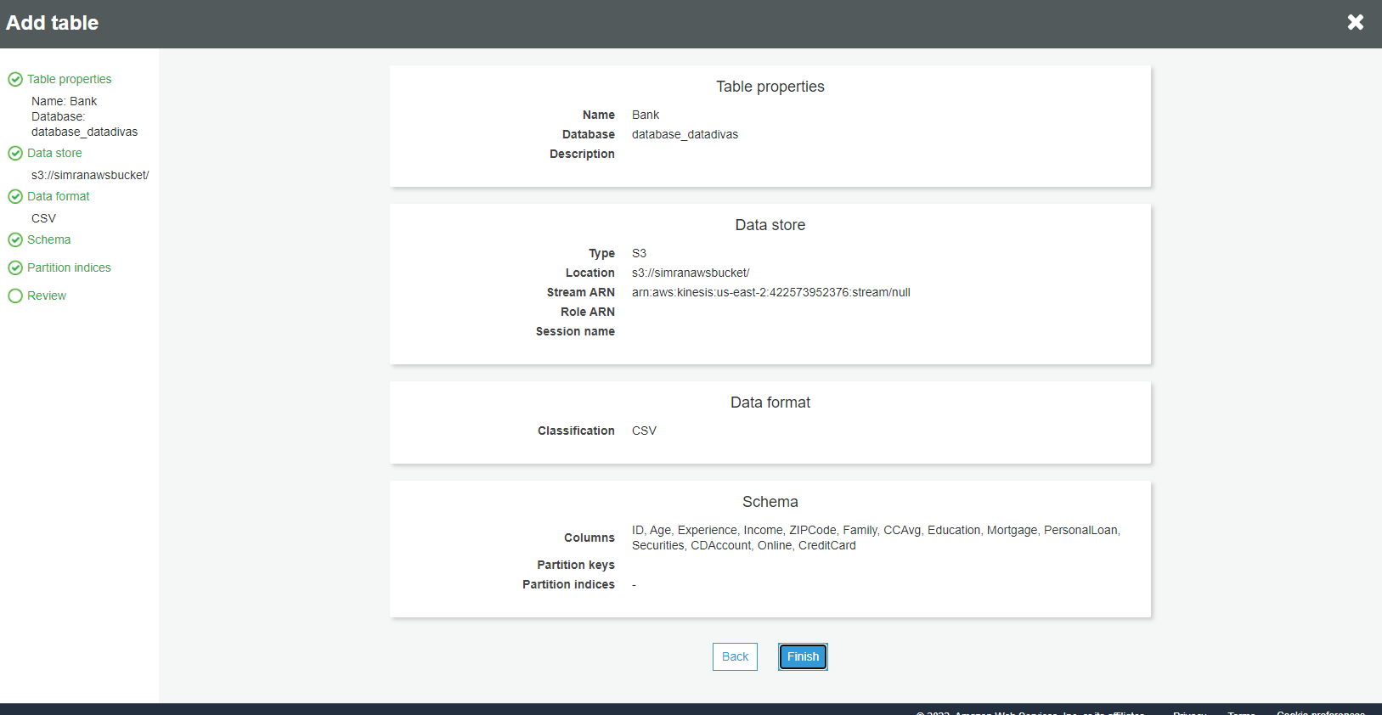

1. Add Connection.

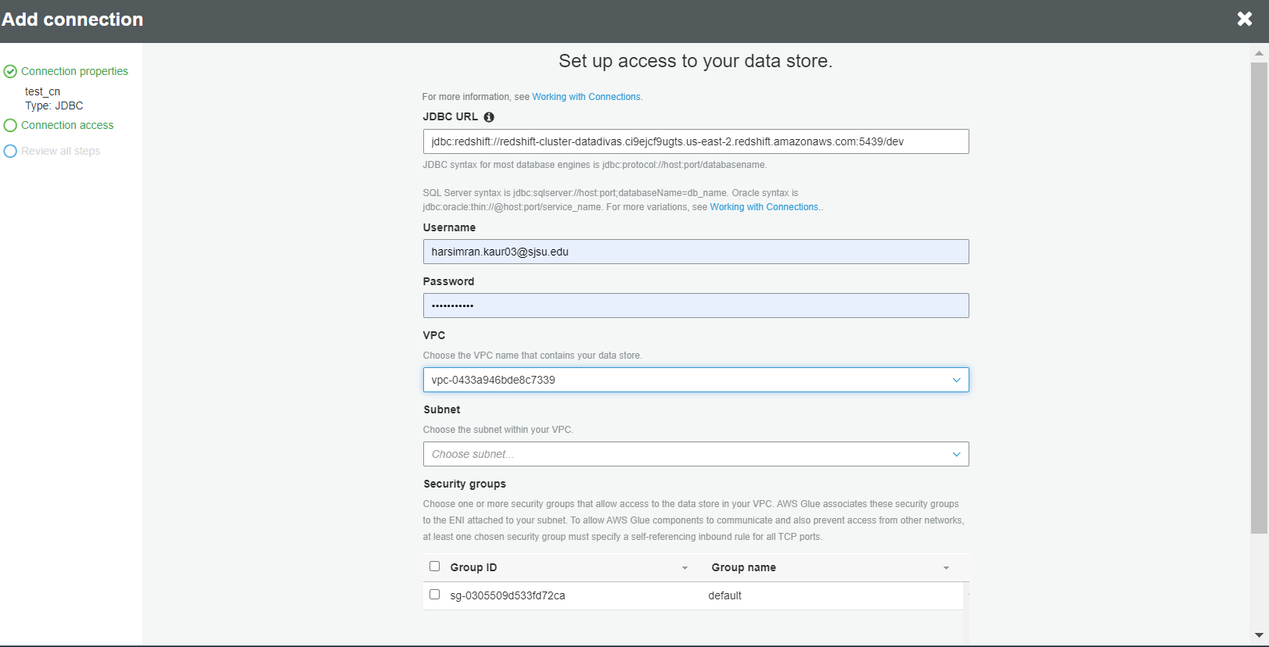

1. Select Connection type “Amazon Redshift” and Click Next.

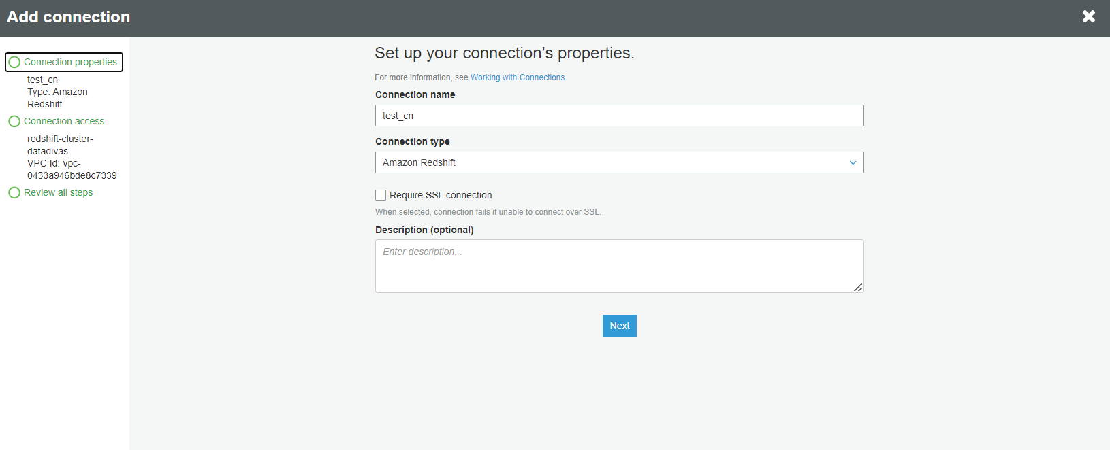

1. Enter the details to your data store.

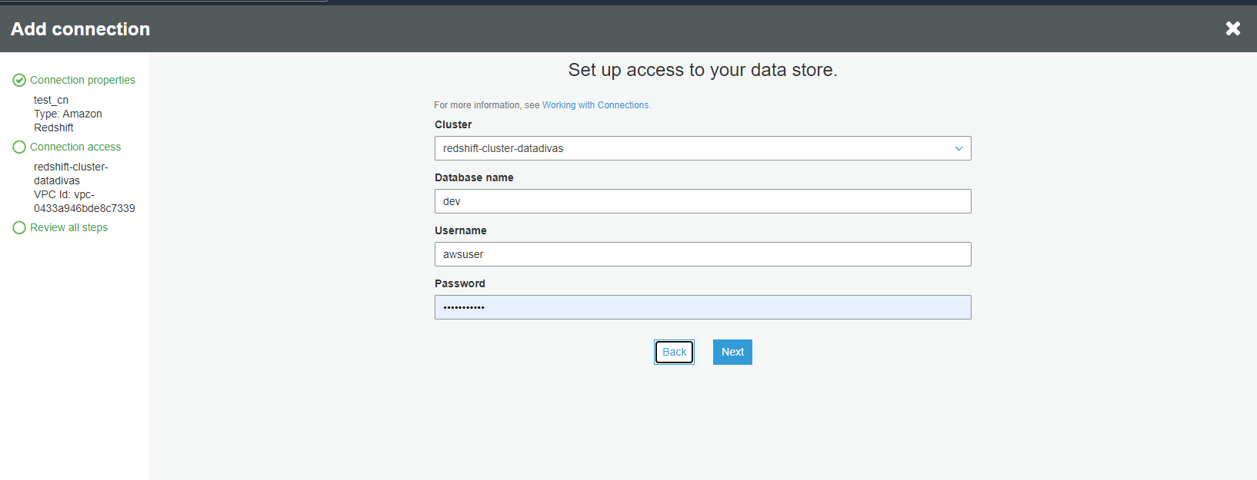

1. Final Review and Click Finish.

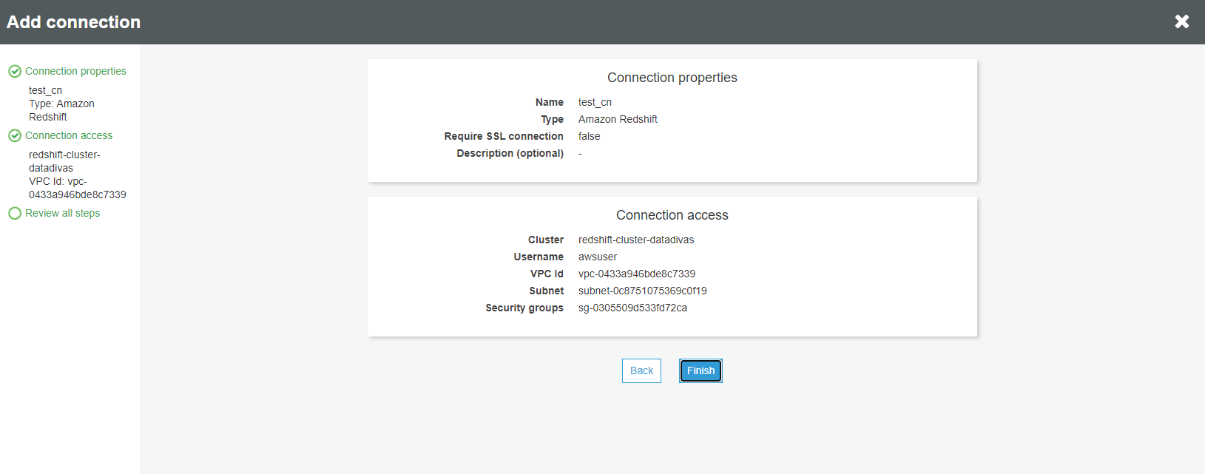

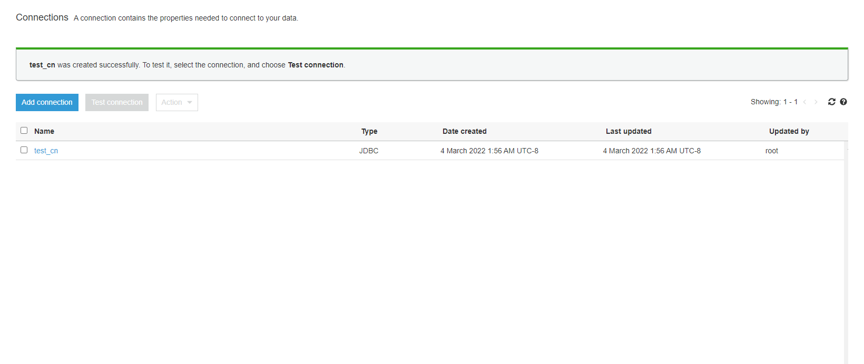

1. Add job

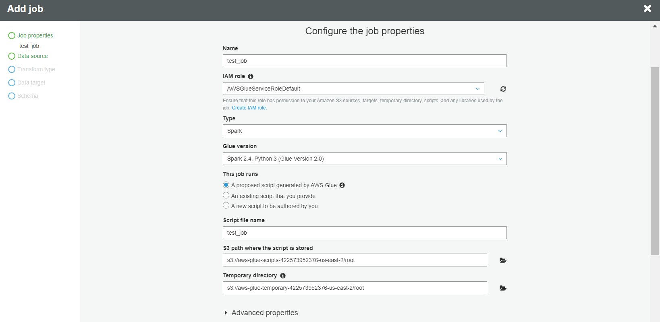

1. Select a data source and click Next

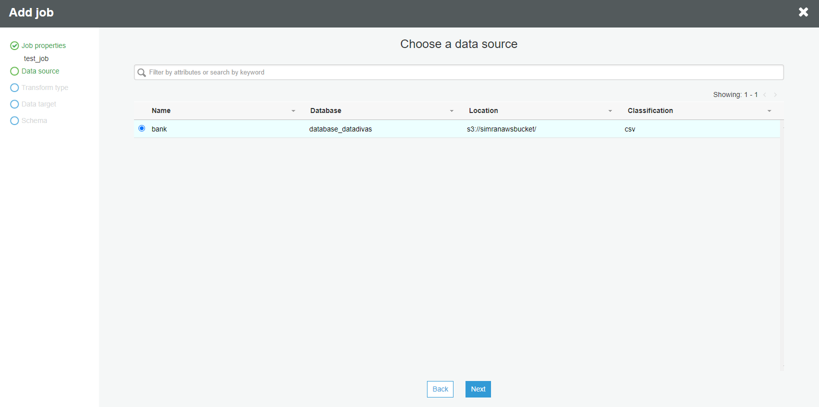

1. Select transform type and select change schema and click next.

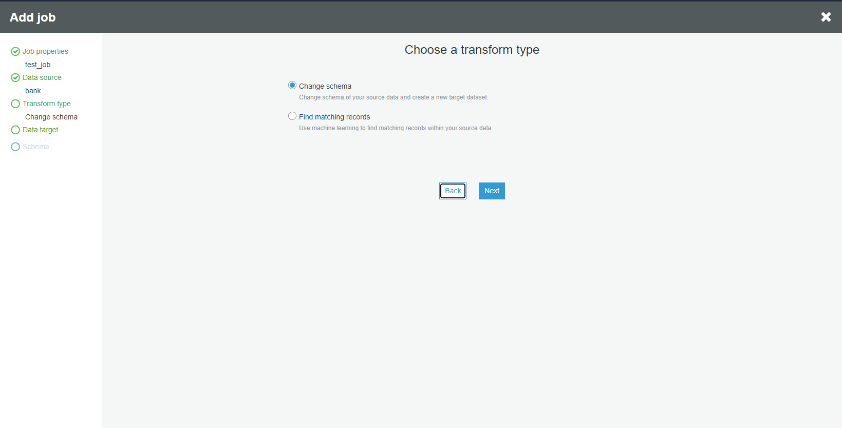

1. Select a data target and click next.

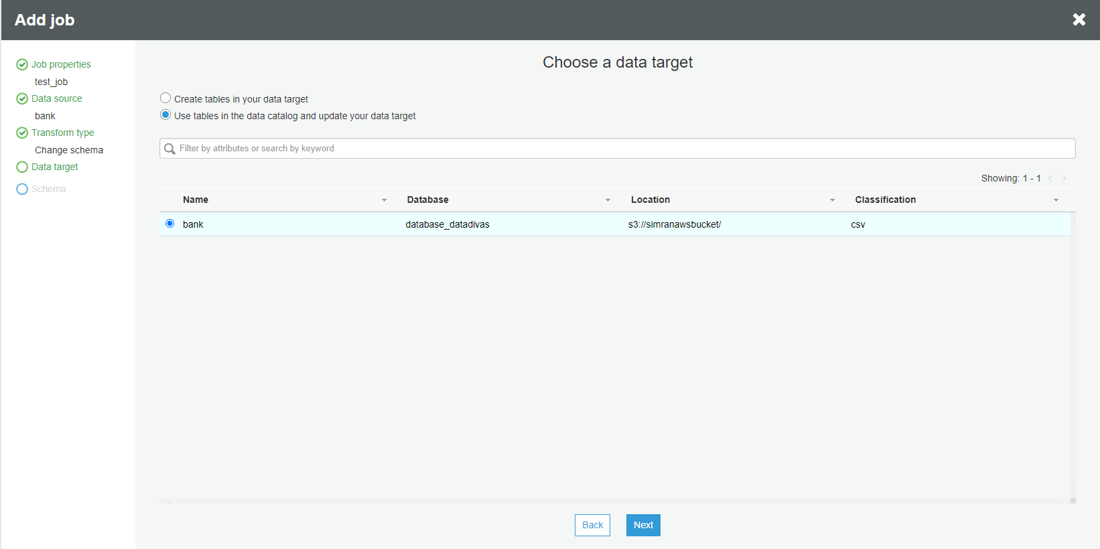

1. Review output schema definition and click save and edit script.

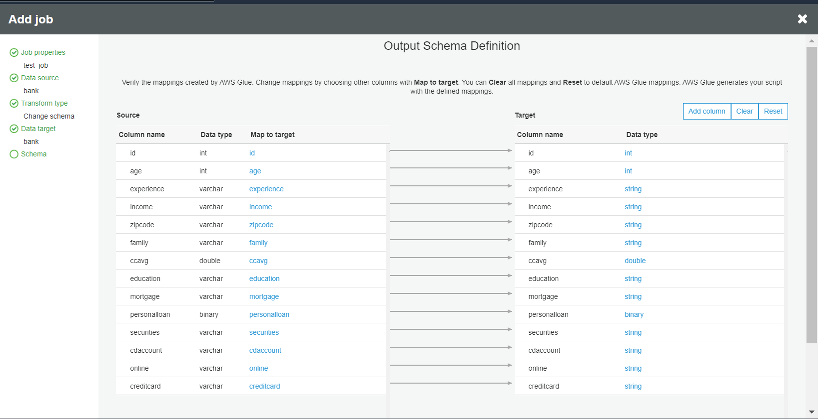

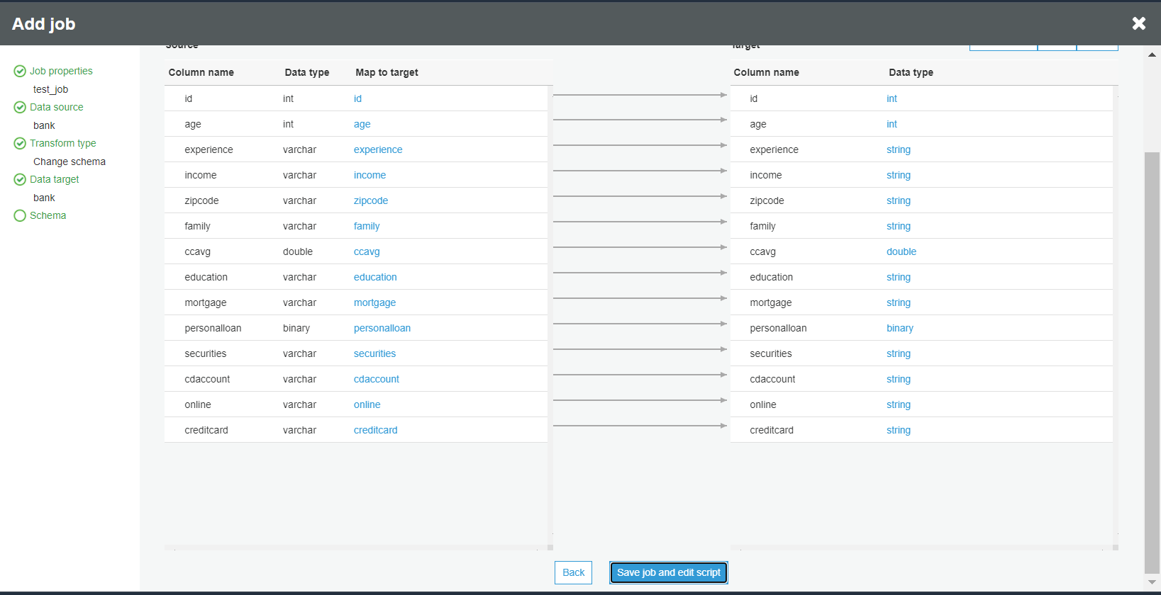

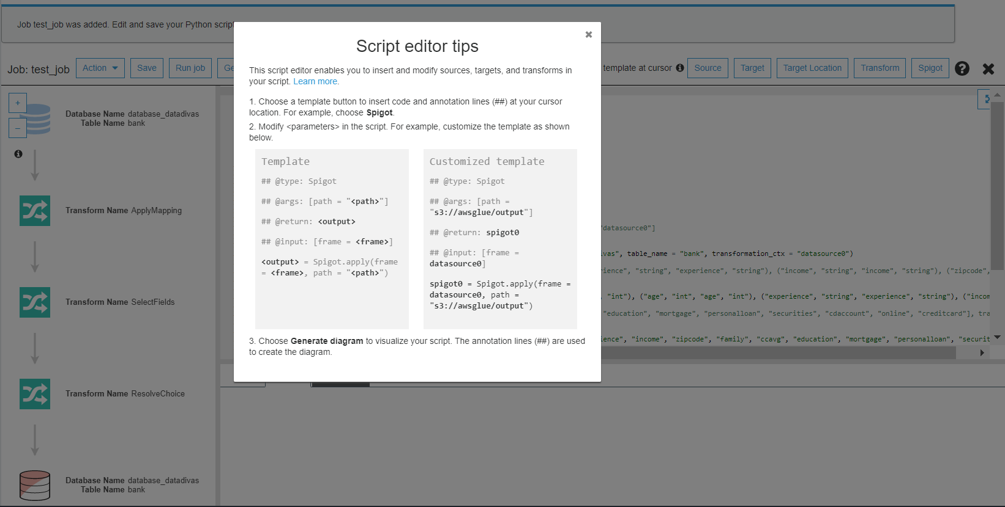

# 

# AWS Glue Console Workflow Overview

1. Add Crawler

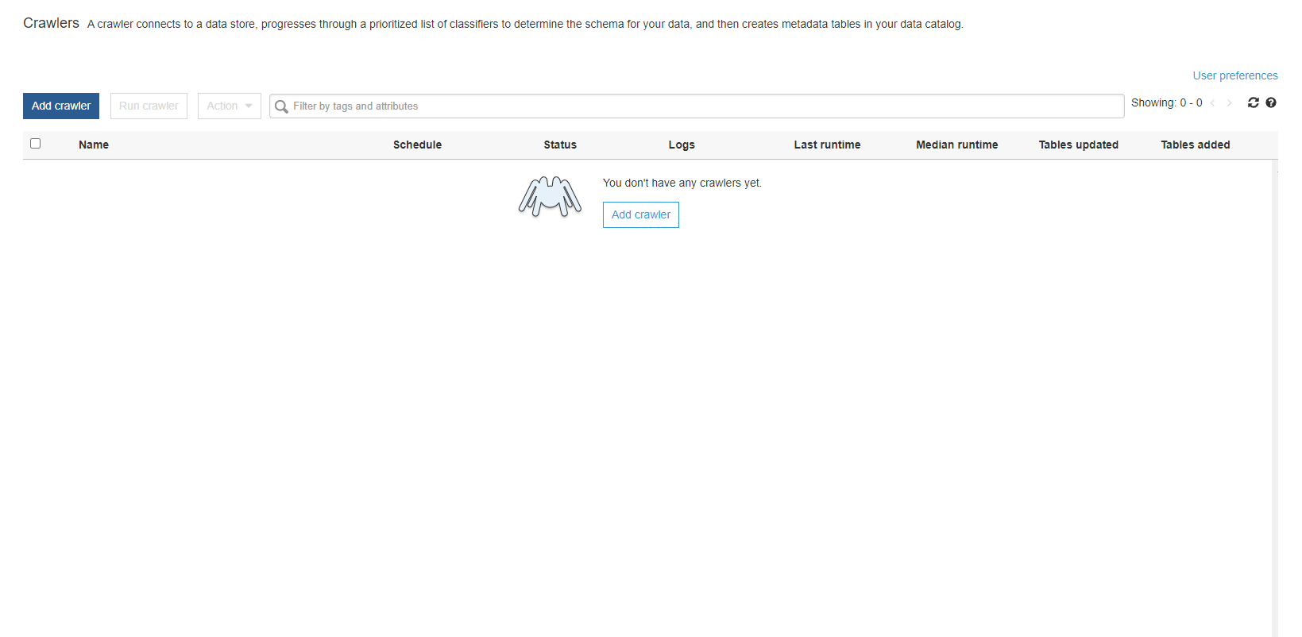

1. Give Name and click next.

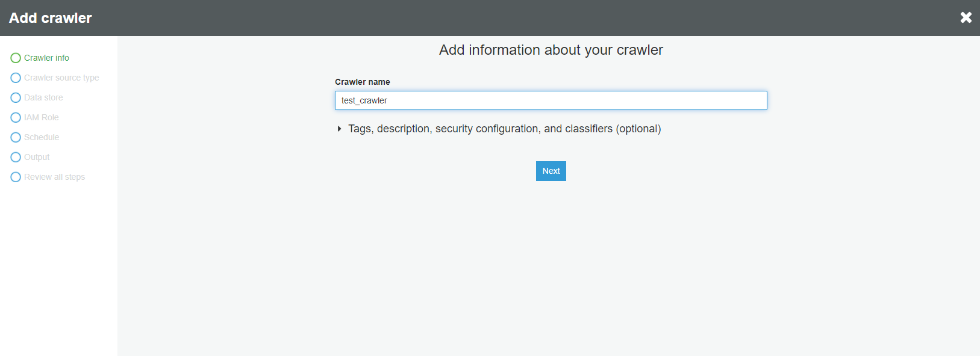

1. Choose Existing catalog tables. Click Next.

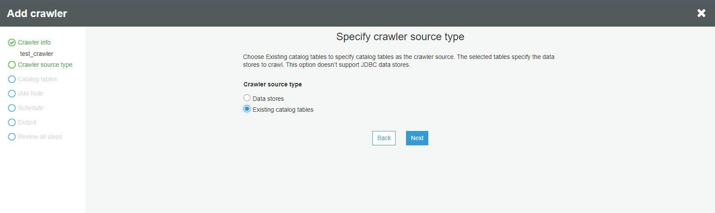

1. Select Add table from available tables and add it to the selected tables.

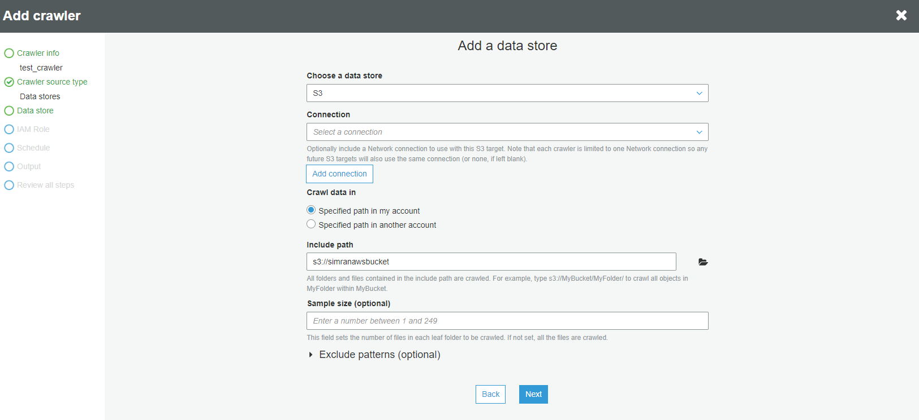

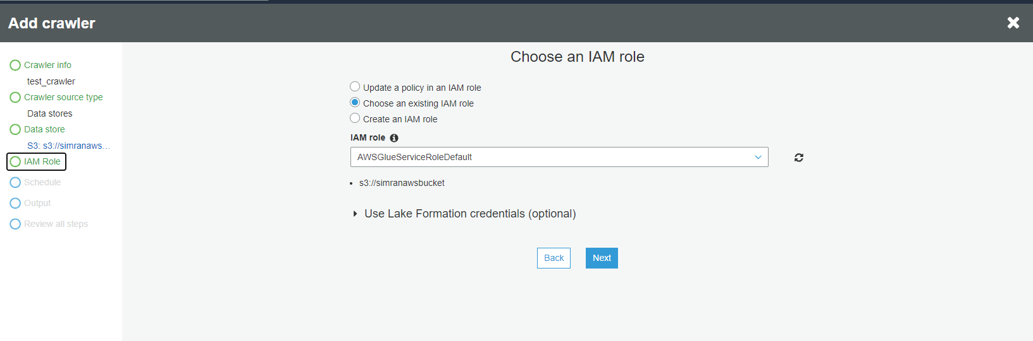

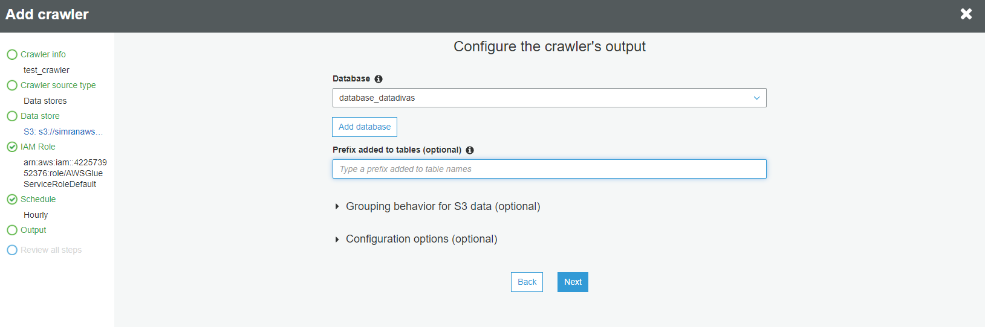

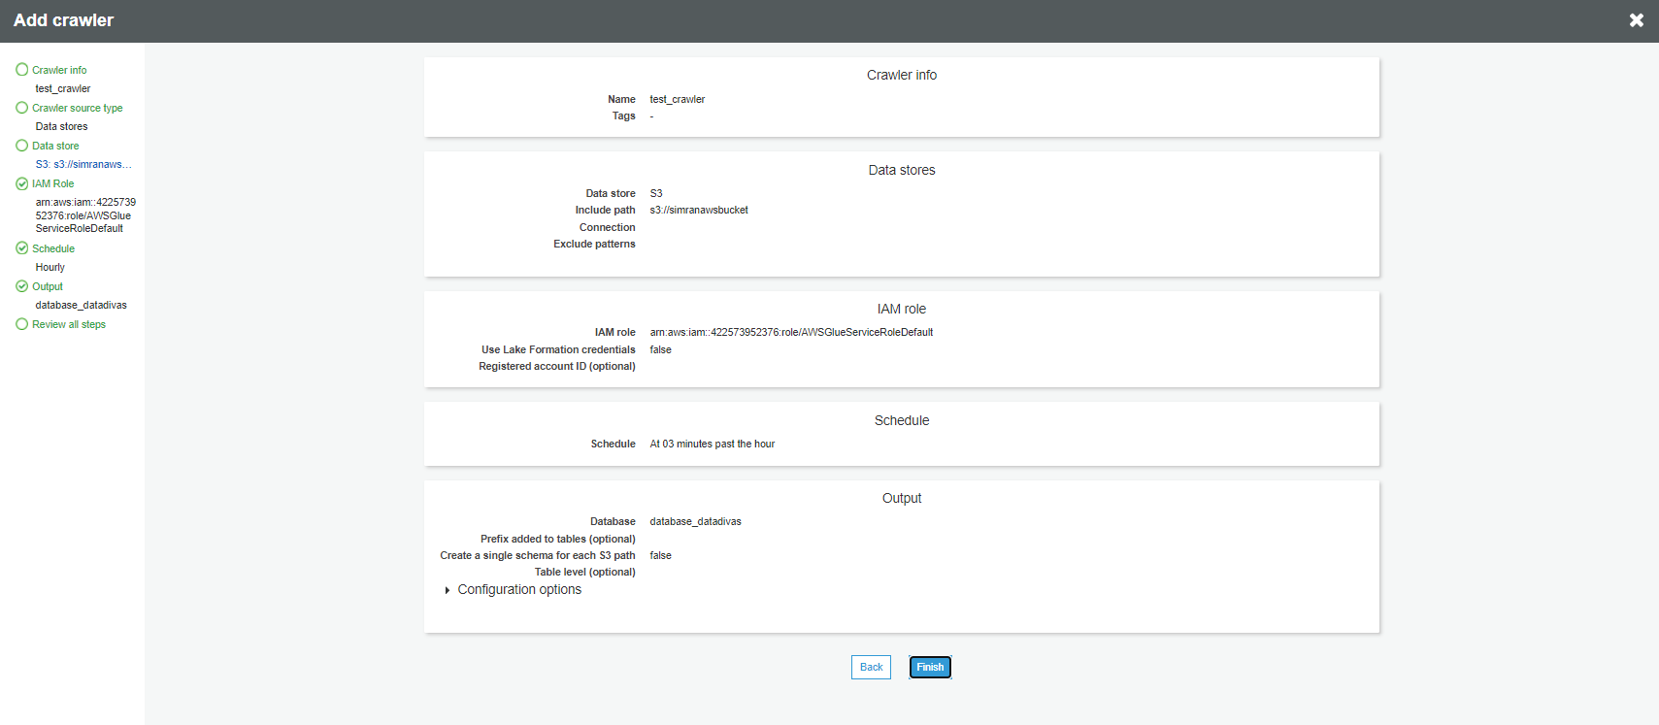

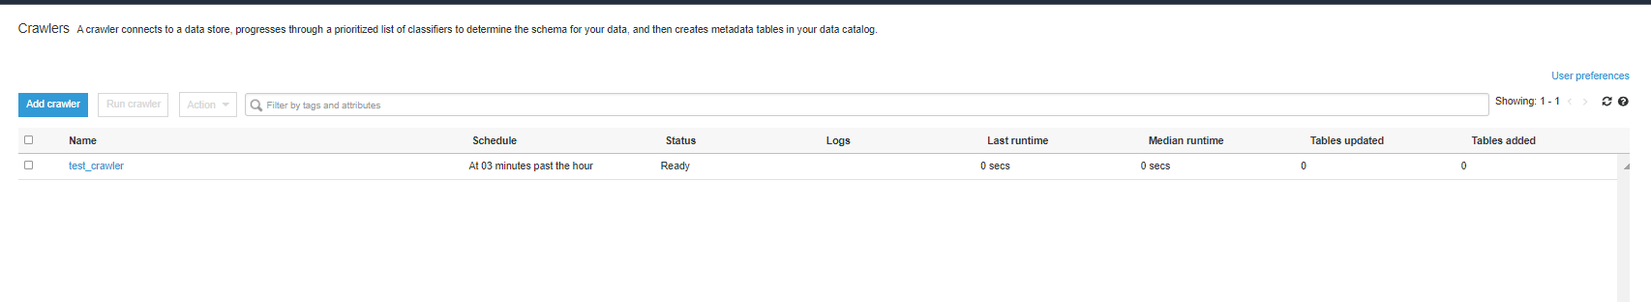

Job Script

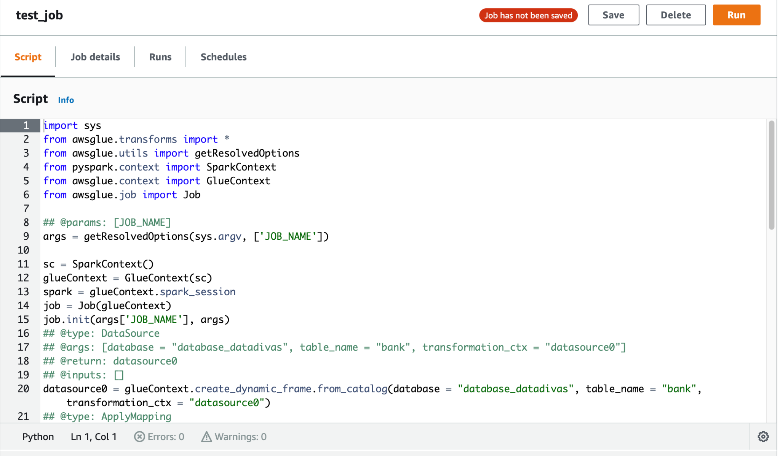



Job Status

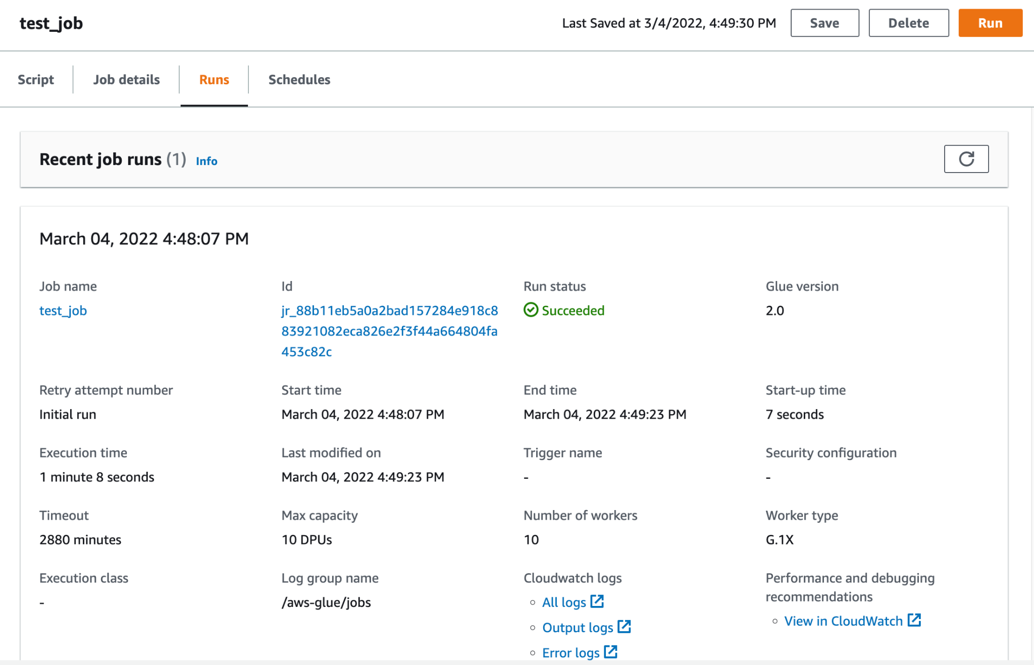

Target Location

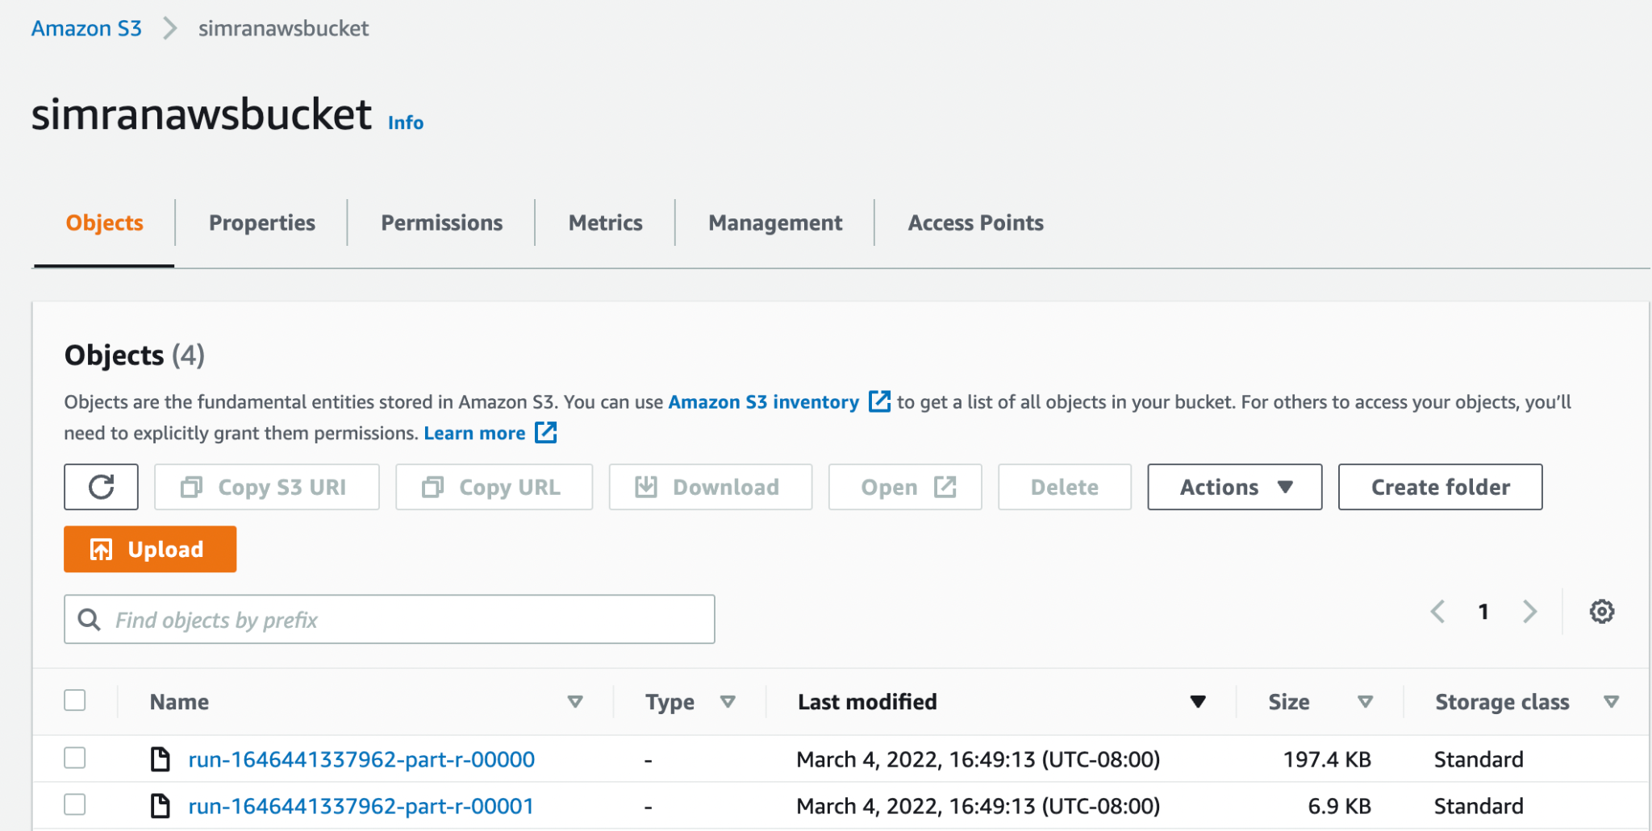

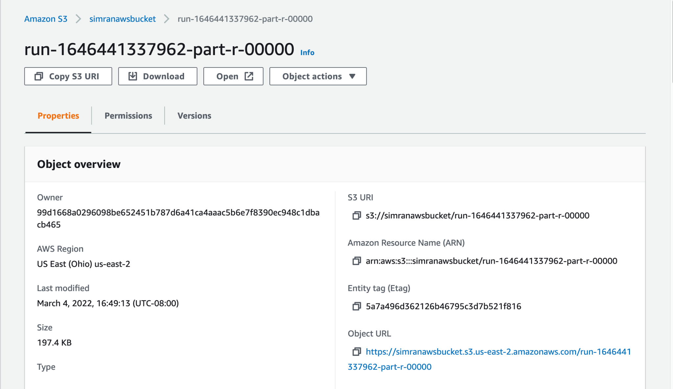

OUTPUT File: Data successfully copied to Amazon S3 Bucket.

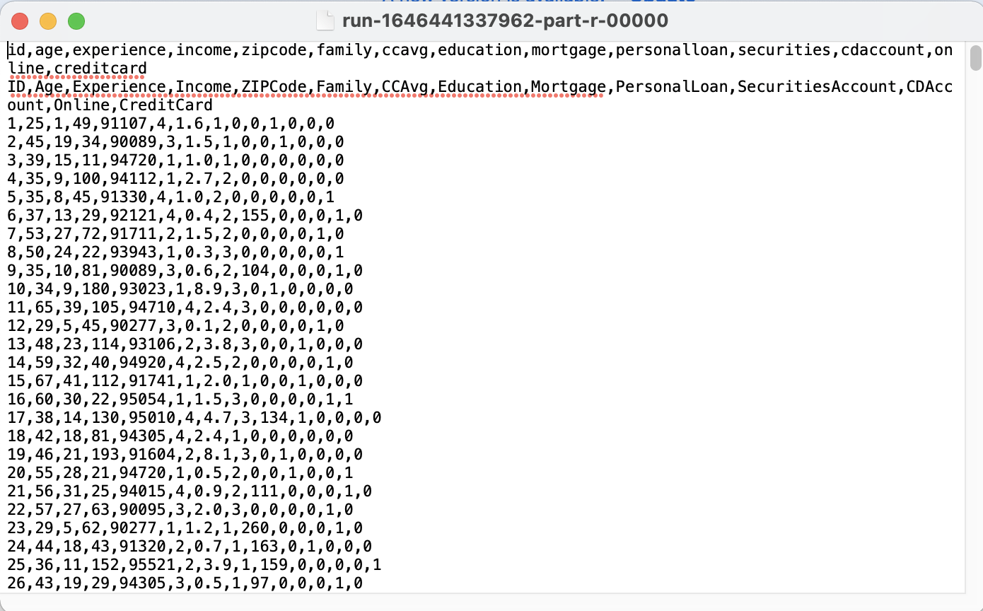

# References

* (2022). Retrieved 8 March 2022, from https://docs.aws.amazon.com/glue/latest/dg/glue-dg.pdf.